**Group-3 (Batch-2)**

**Comprehensive Retail Sales Analysis, Case Study**

**Group Members-**

Nimish Birla

Nirati Khanna

Saumya Gupta

Shyam Tibrewal

Siddhi Saxena

**Problem Statement-**

In the realm of retail, making informed decisions based on historical data is crucial. The challenge arises when strategic choices are influenced by limited historical records, especially for events that occur annually, such as holidays and major promotions. This challenge is exacerbated by the fact that significant events, like holidays and markdowns, have a considerable impact on sales, making it necessary to anticipate the effects on specific departments and overall performance. This project focuses on leveraging historical sales data to engineer a data-driven solution for the company's decision-making processes. The dataset encompasses sales data from 45 stores distributed across various regions, each housing multiple departments. The company's operational strategy includes several promotional markdown events, each aligned with key holidays like the Super Bowl, Labour Day, Thanksgiving, and Christmas. Worth noting is the fact that week’s containing these holidays hold five times the significance of non-holiday weeks during evaluations.

**Objectives-**

The objective of this data engineering project is to construct a robust data pipeline that effectively integrates, cleanses, and transforms the provided data. The pipeline should be designed to prepare the data for subsequent analysis, focusing specifically on quantifying the impact of holidays and markdowns on sales performance across different departments and stores. By engineering this data pipeline, the project aims to facilitate comprehensive decision-making based on historical trends, enabling the company to better anticipate and manage the effects of promotional events and holidays on its bottom line. For the data engineering solution, a comparative study of several approaches will be performed to build an appropriate system for campaign classification. The first step in this process will involve data pre-processing and cleaning to address data quality issues identified during the exploratory analysis.

**Data Flow Diagram -**

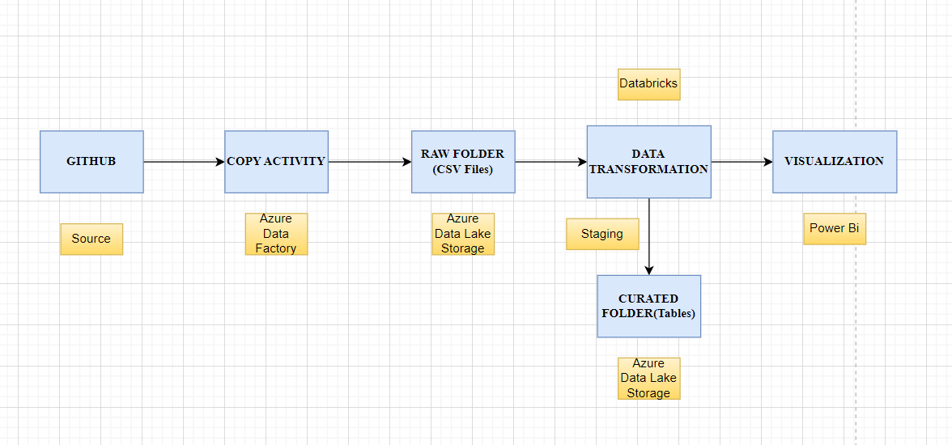

**GitHub account creation -**

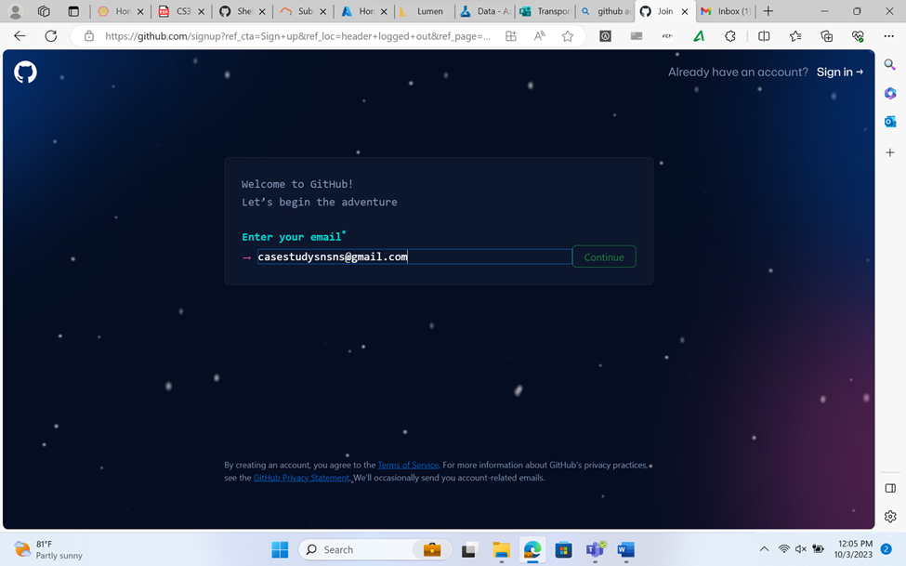

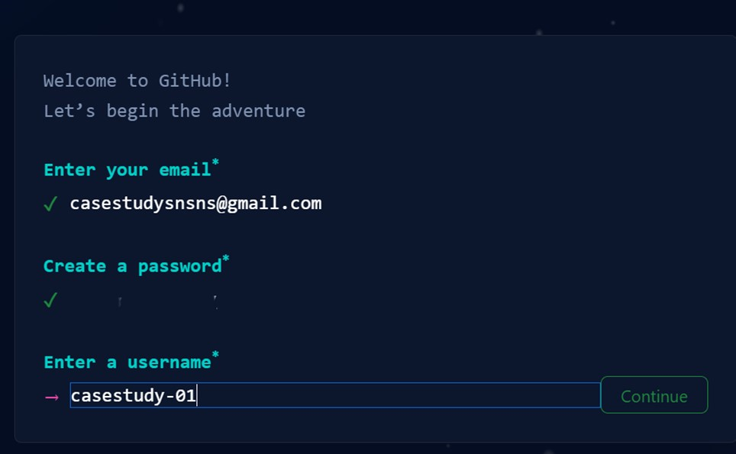

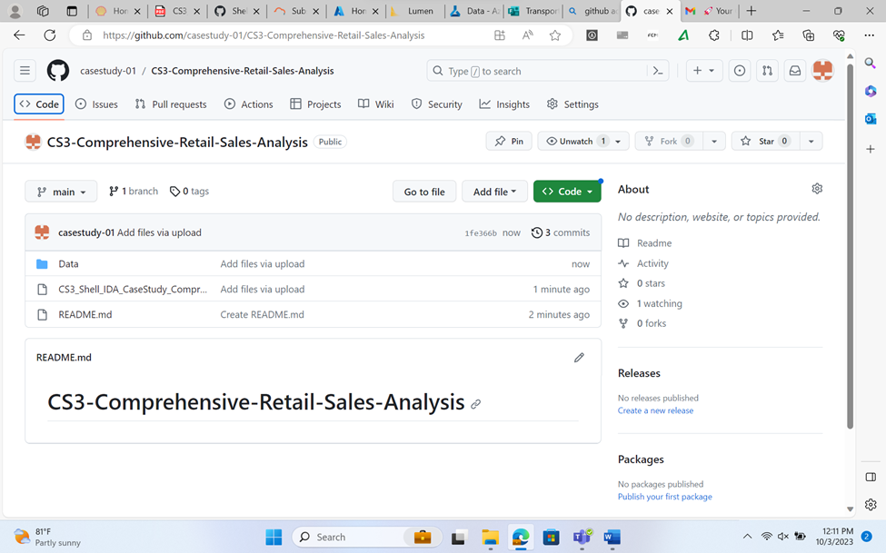

**Data Management and Storage-**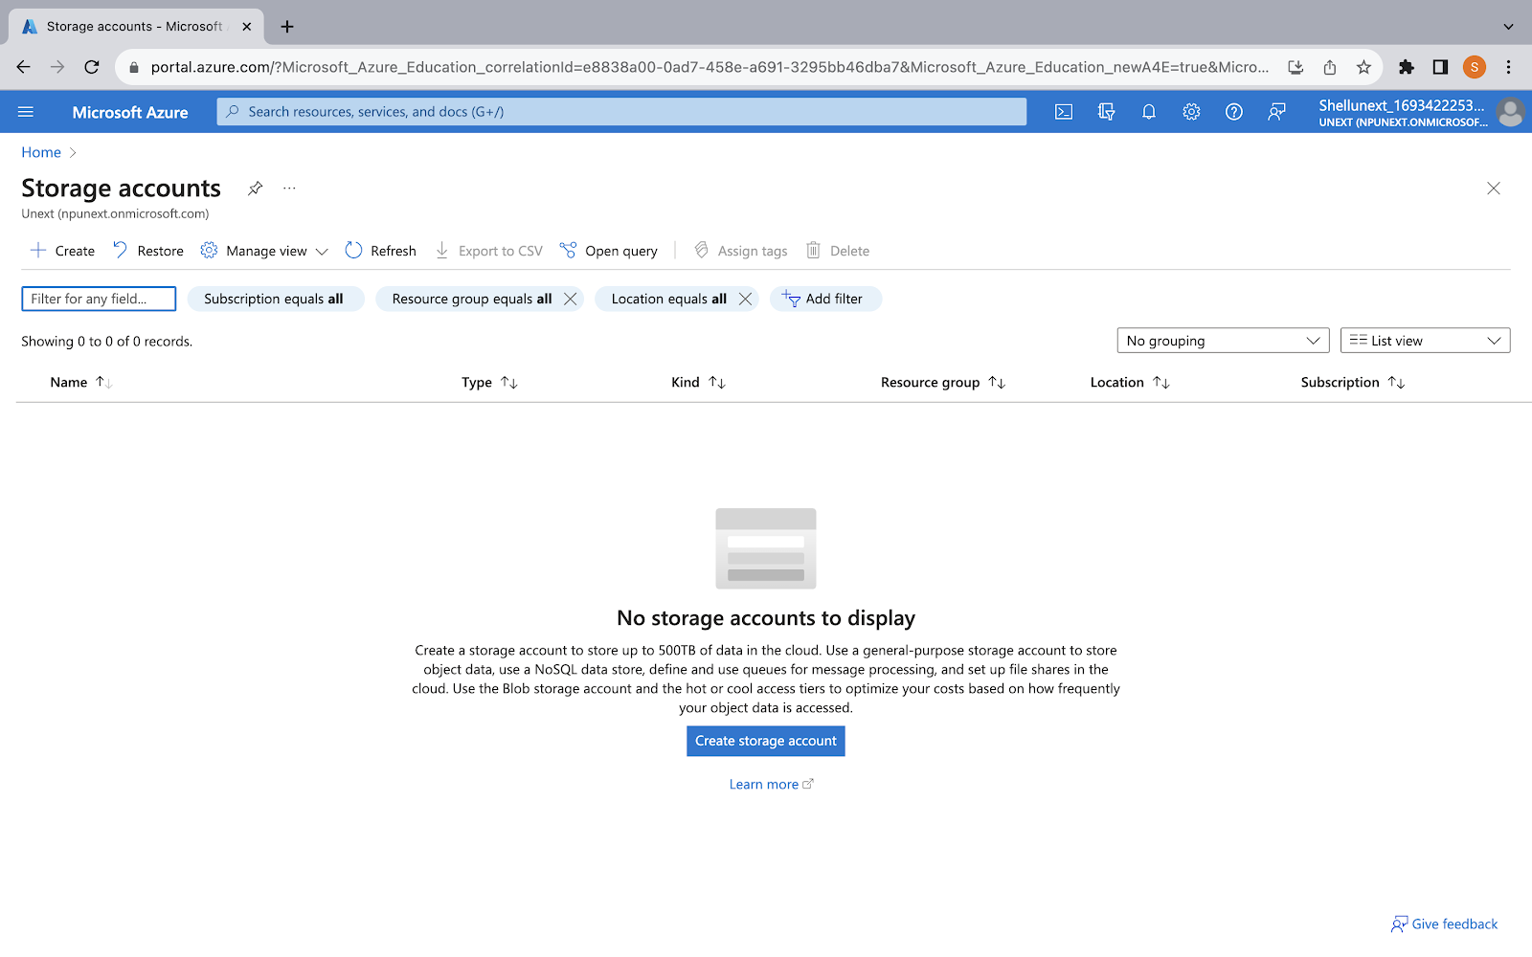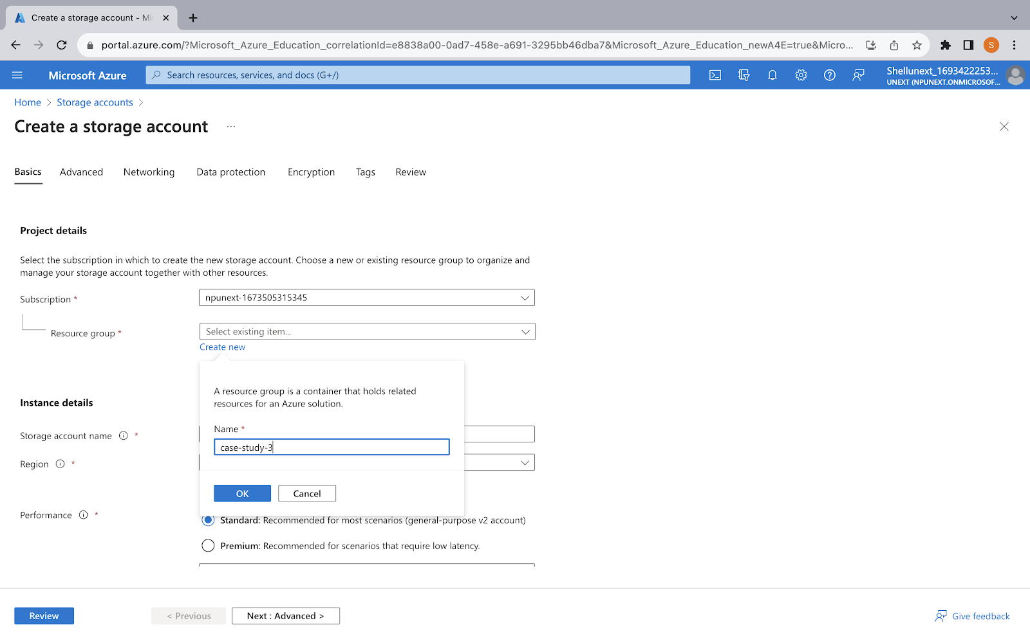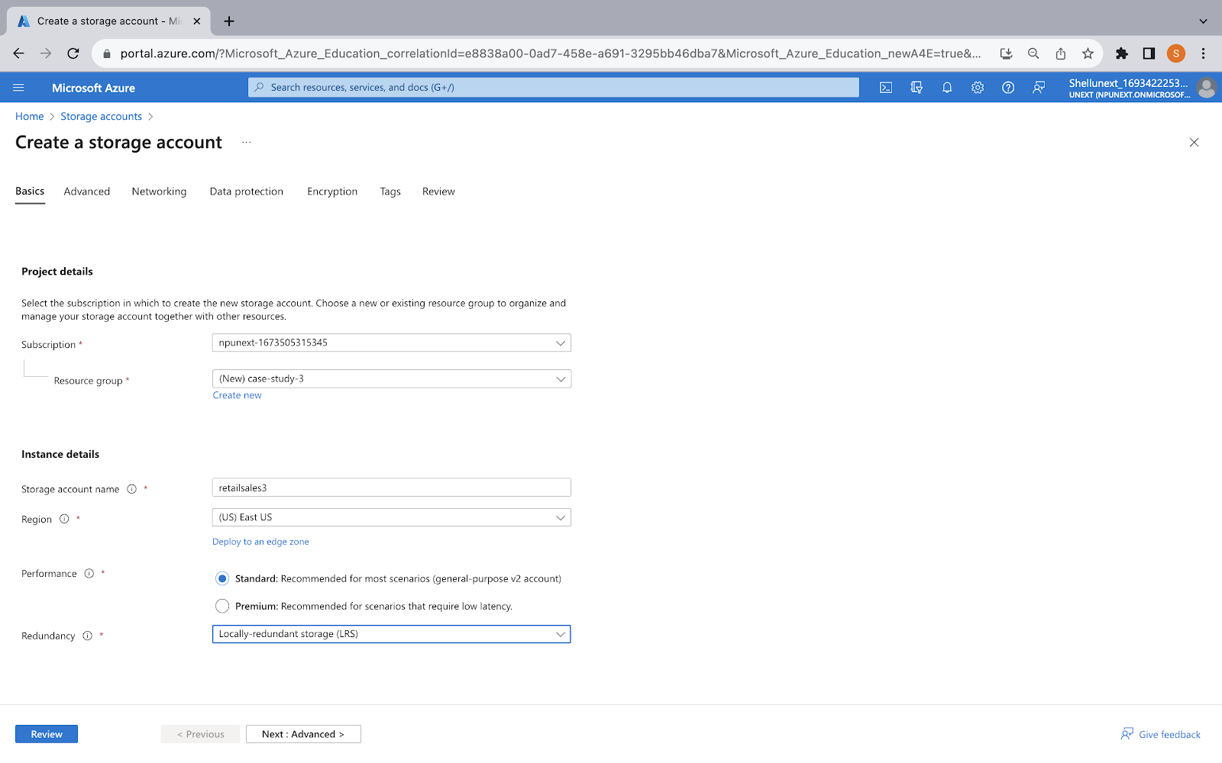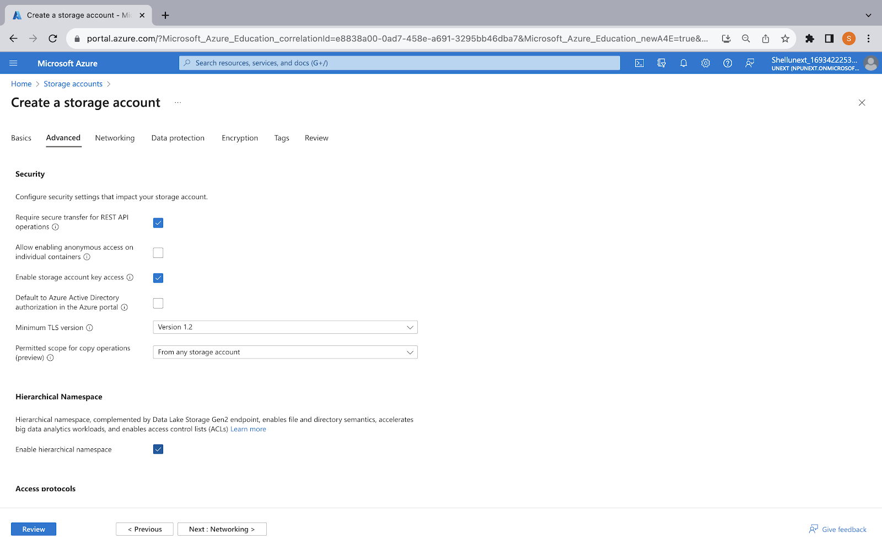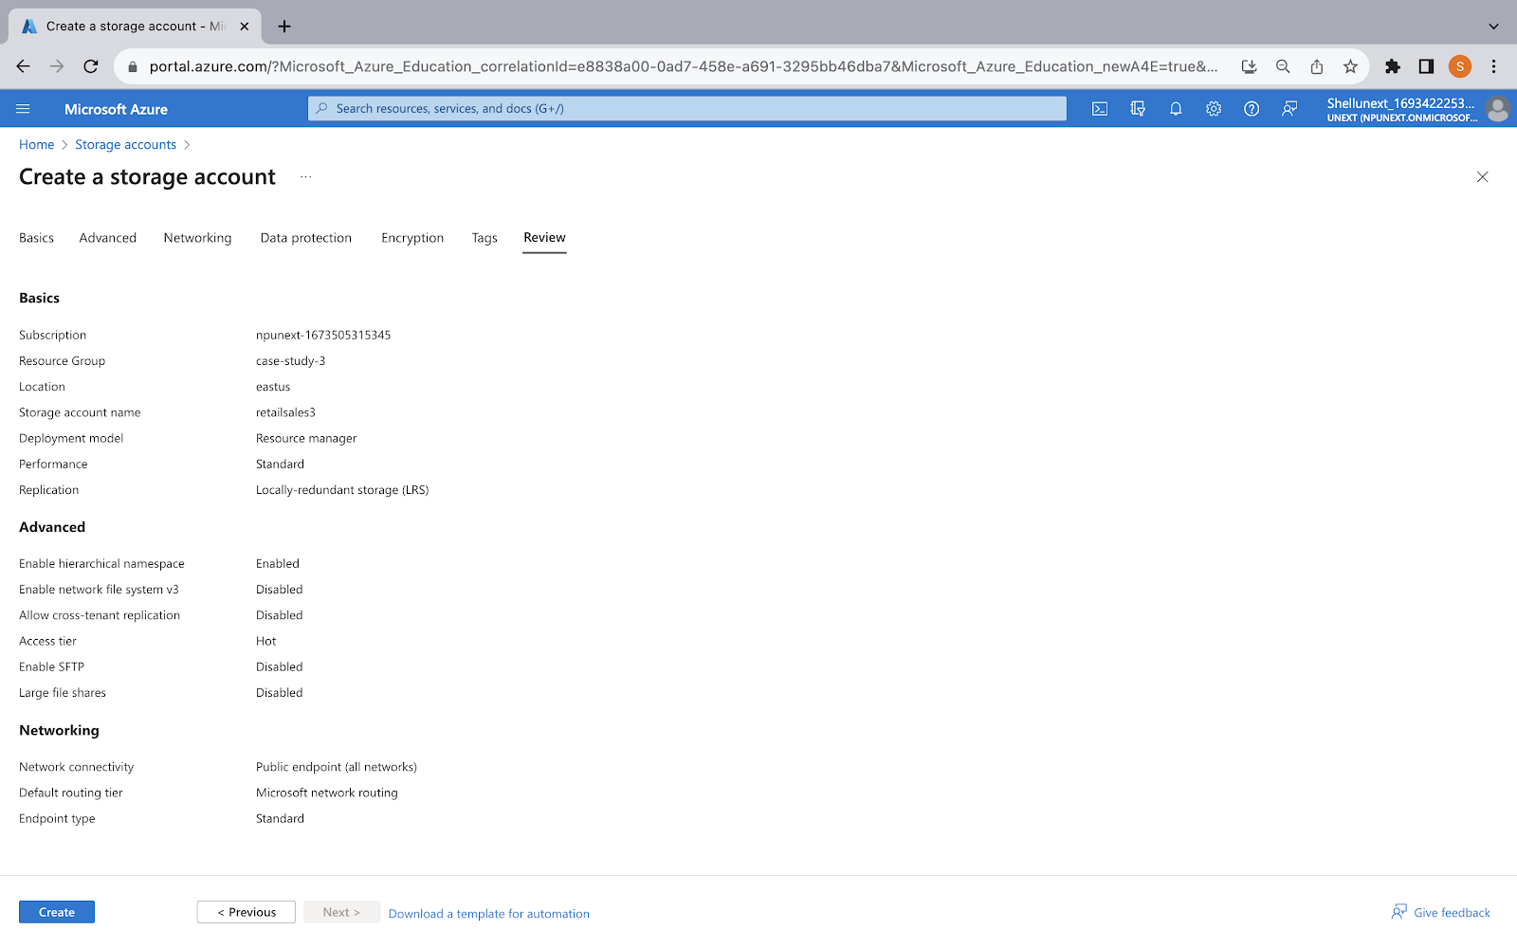

**Data Ingestion -**

Data Factory

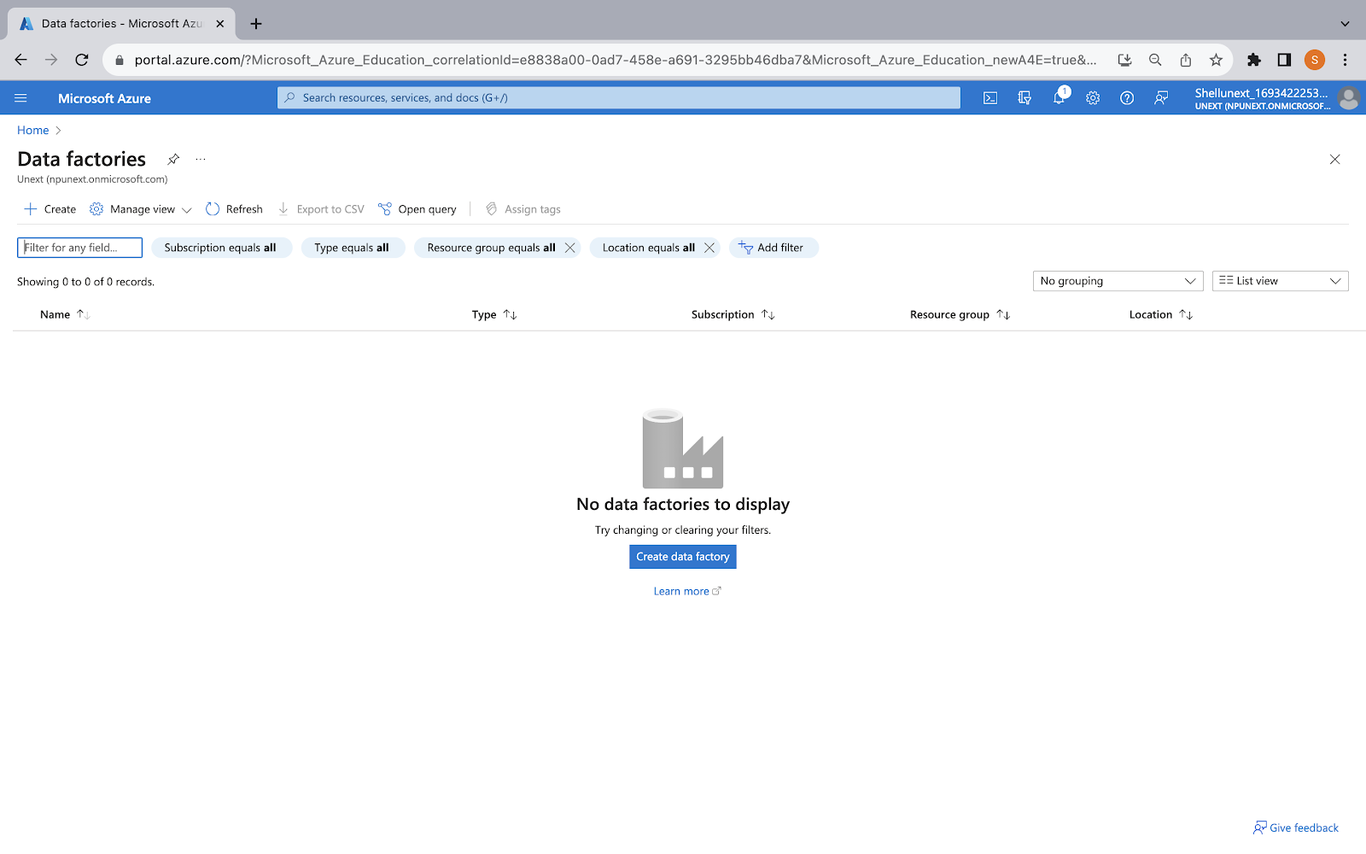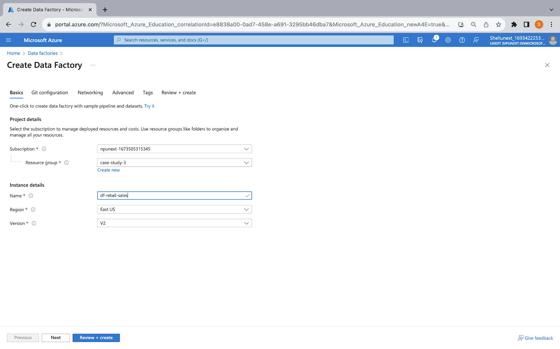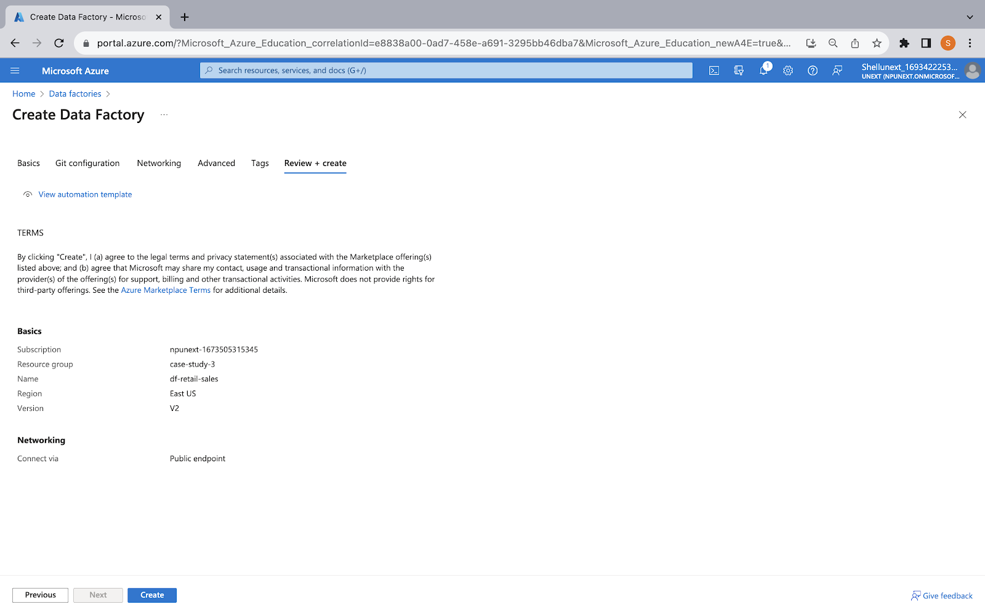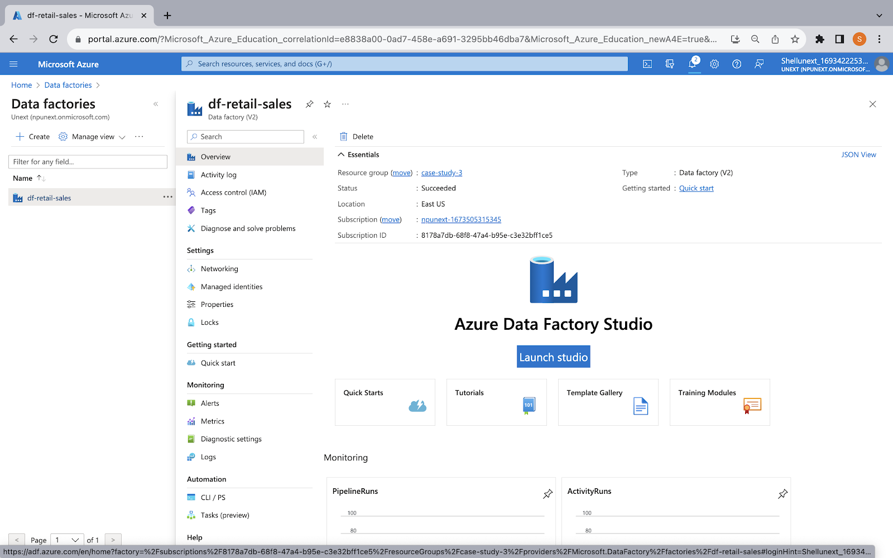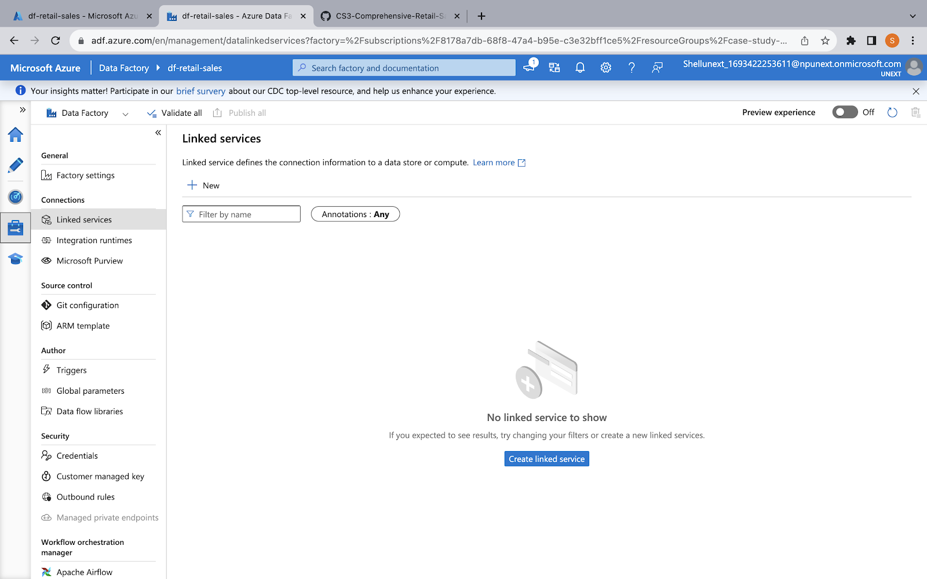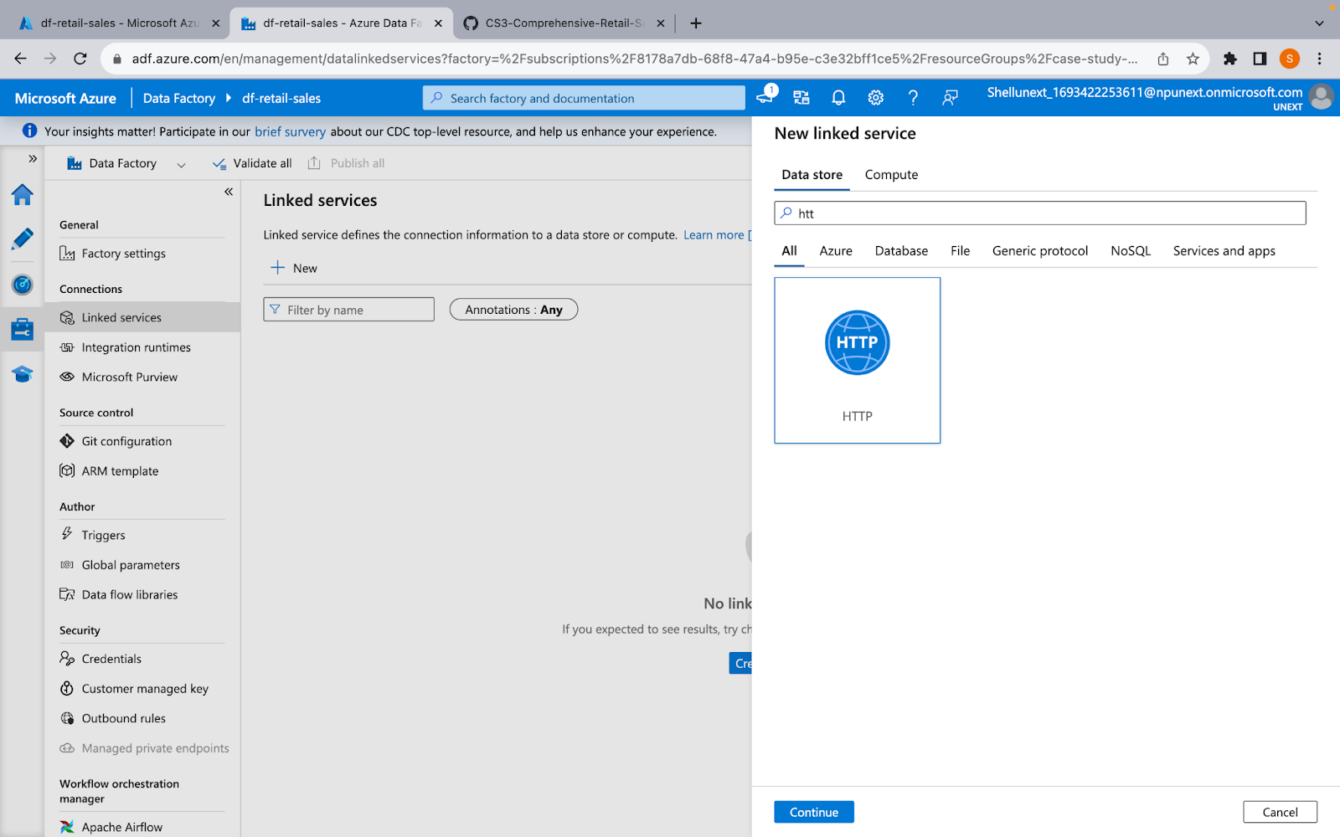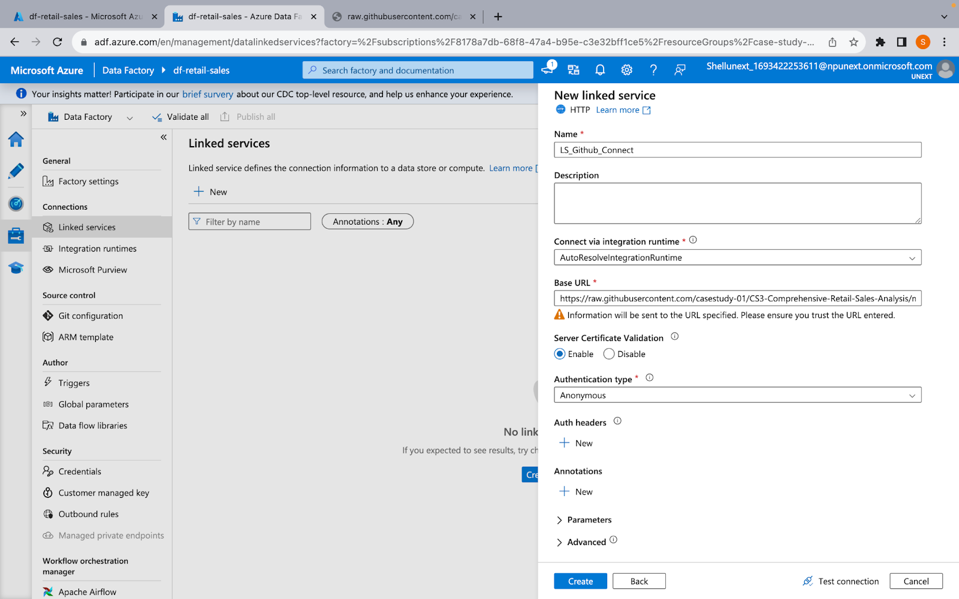

Linked Service - ADLS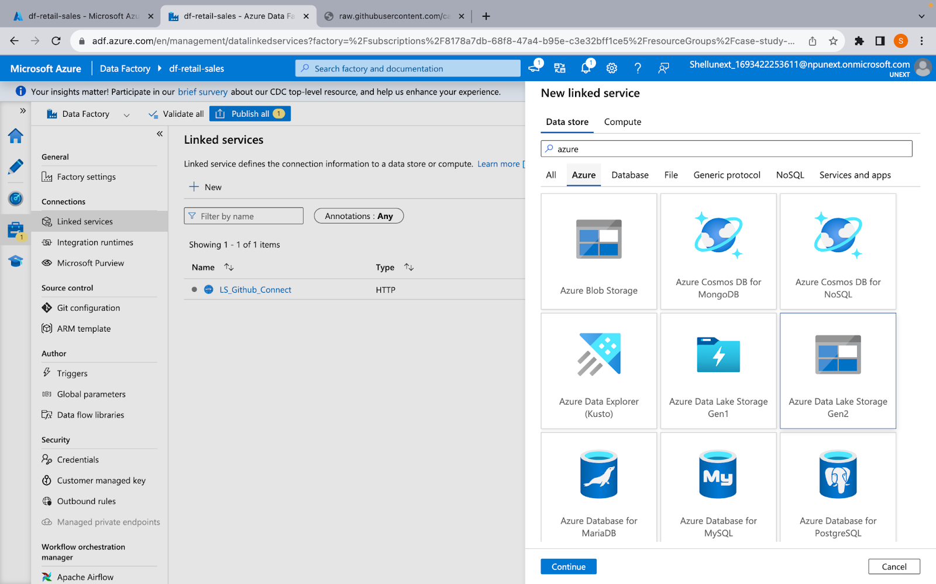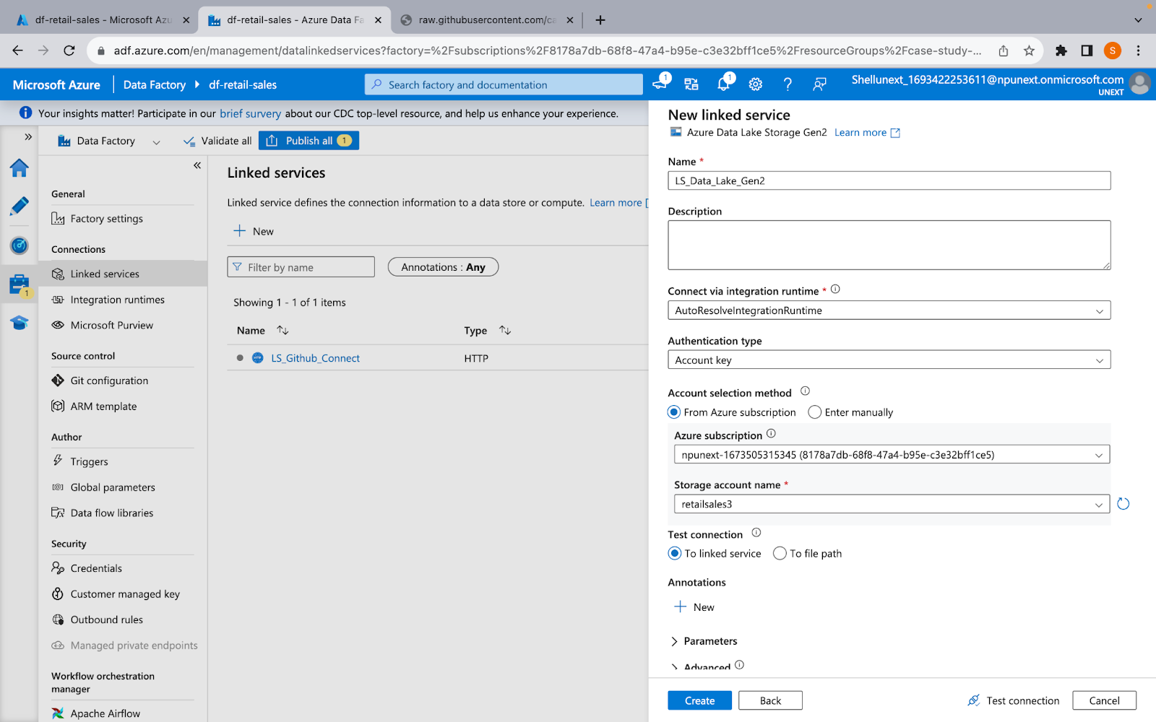

Creating Dataset

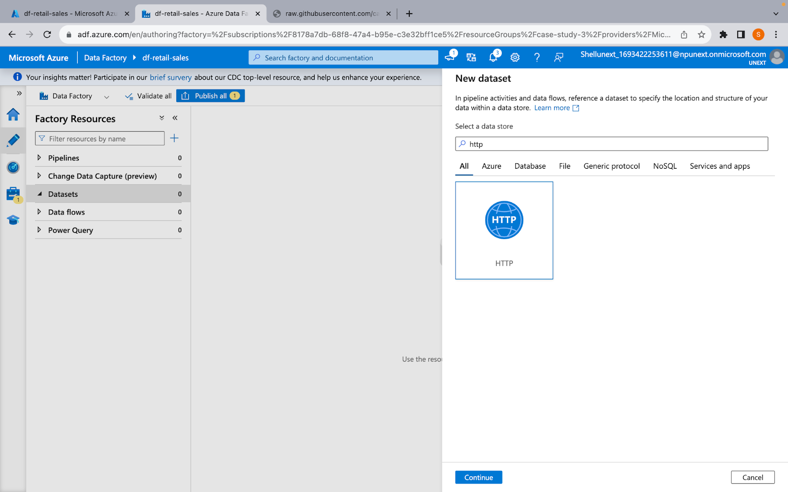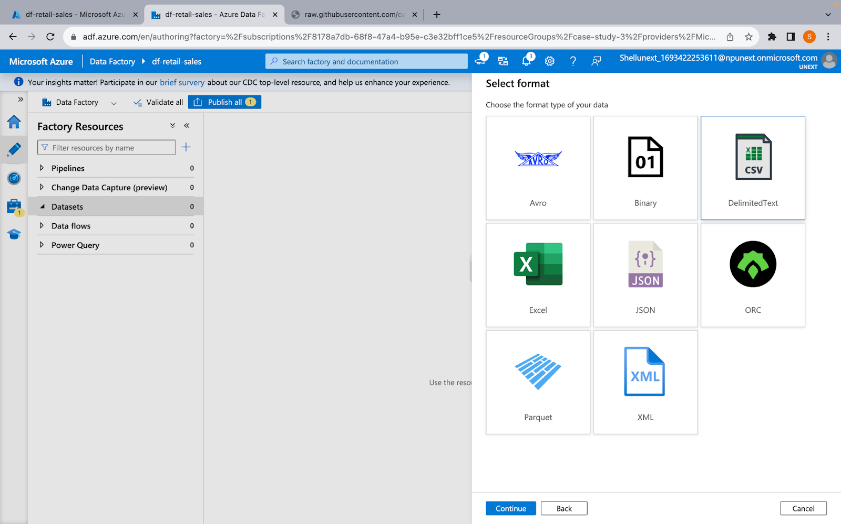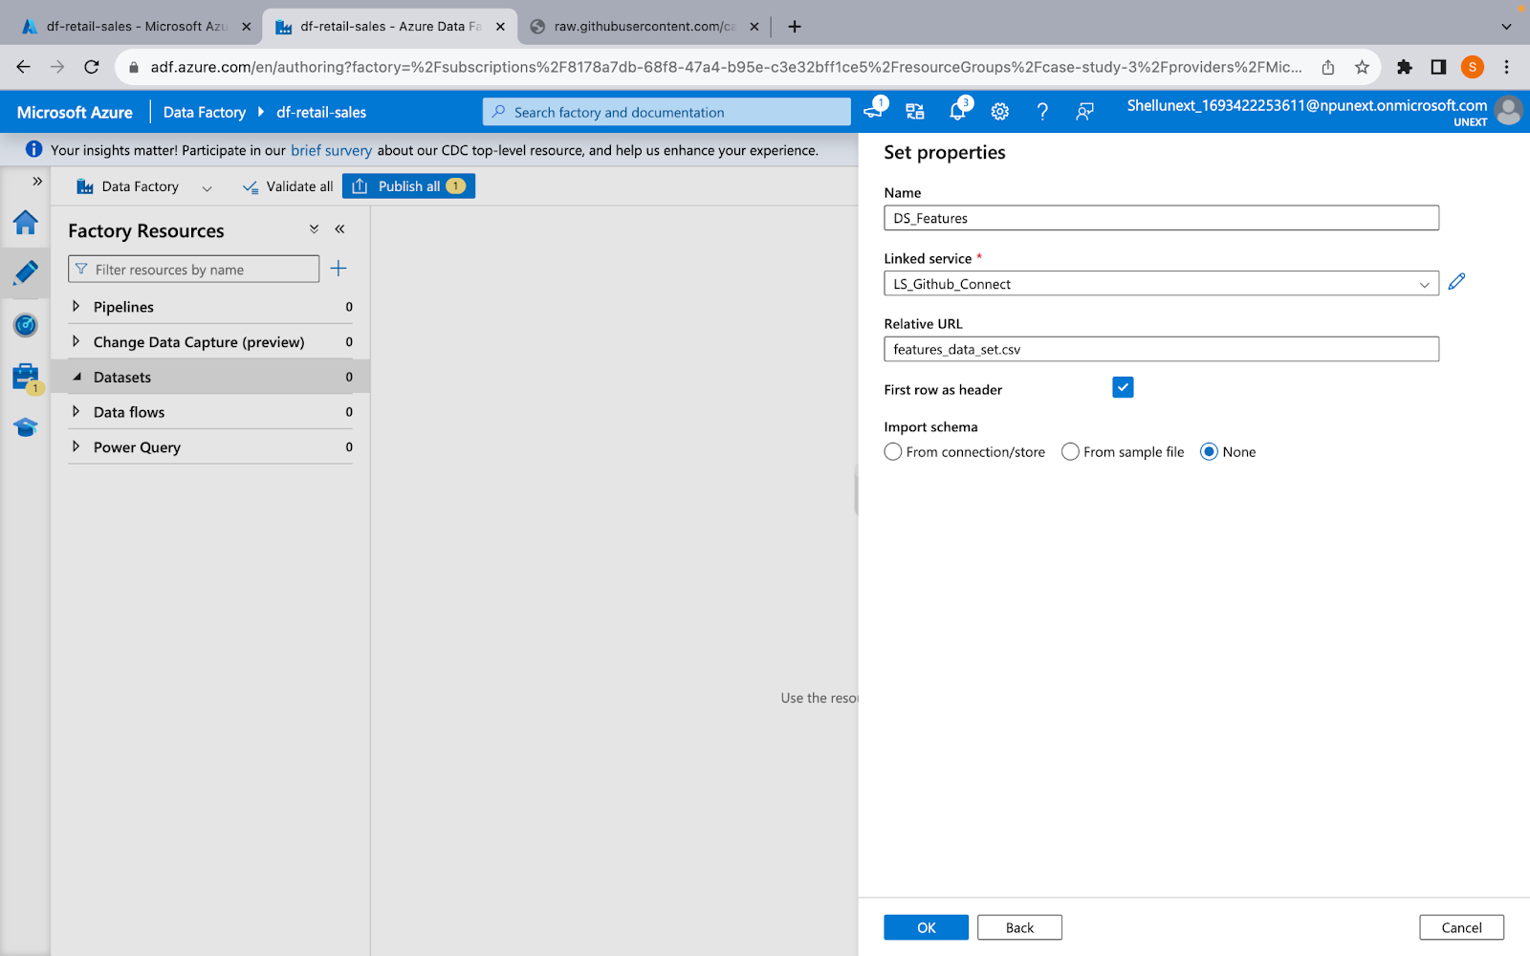Creating DS for RAw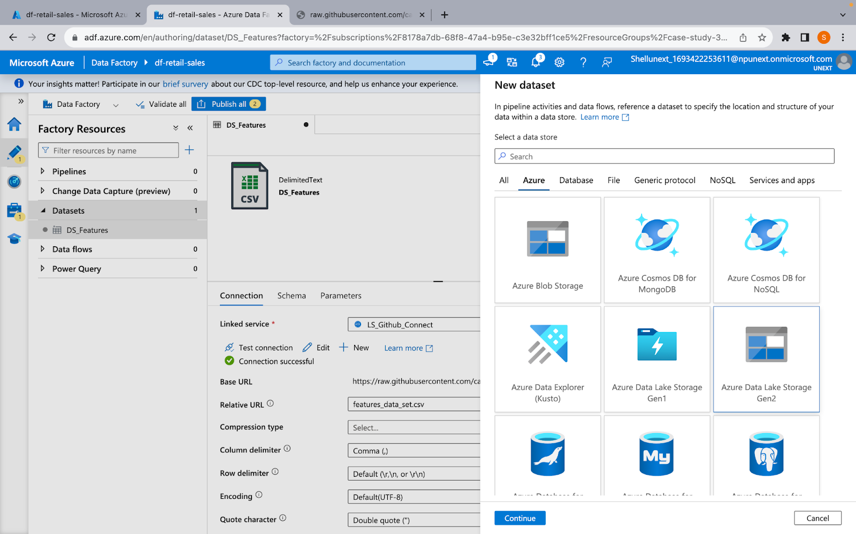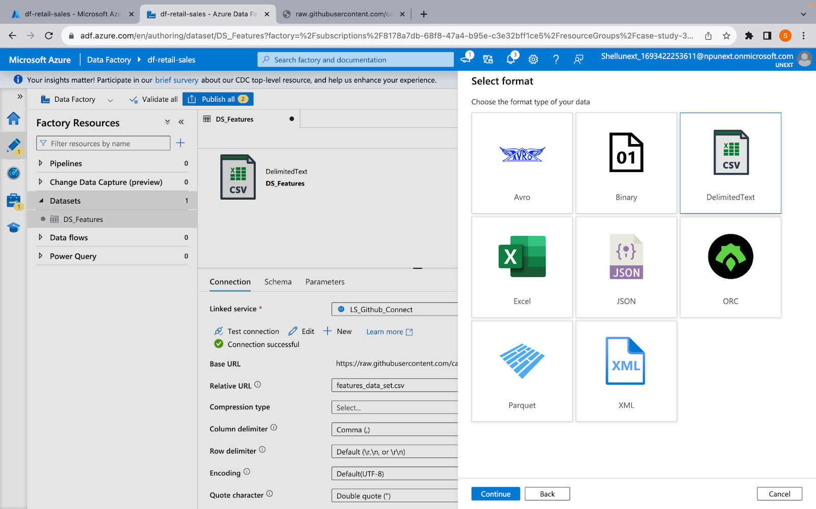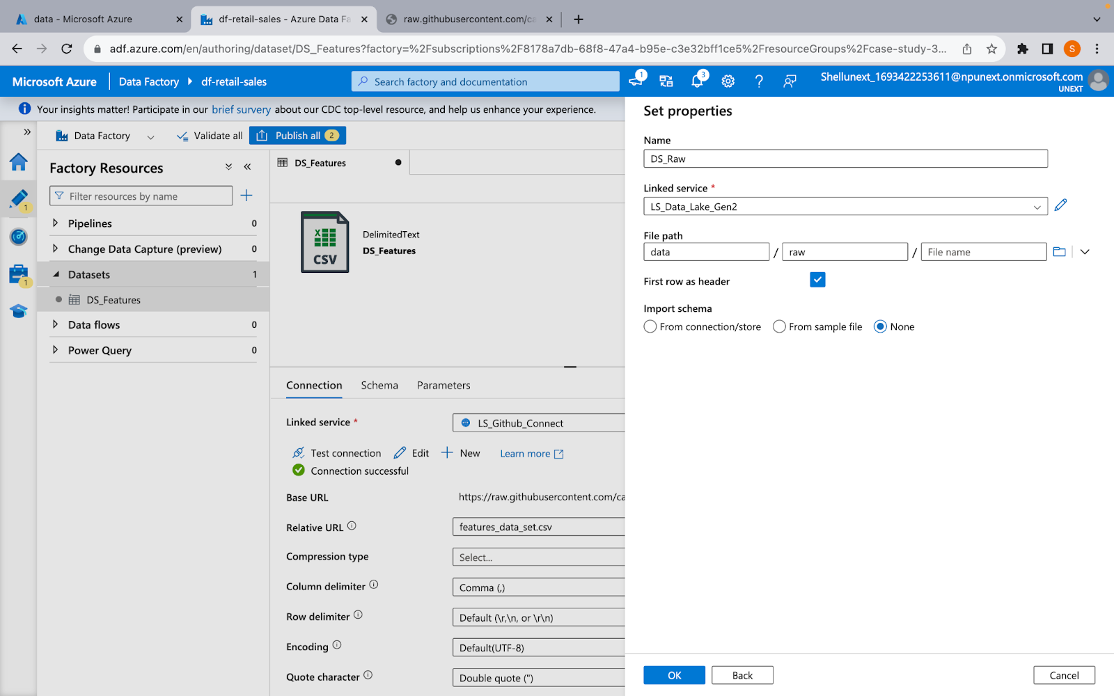

ADLS Configuration

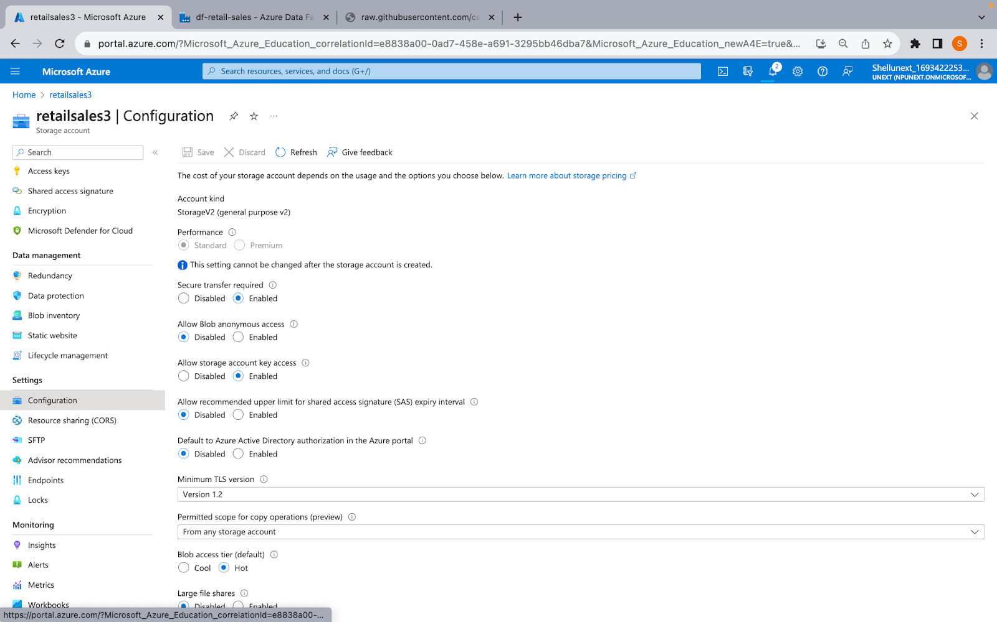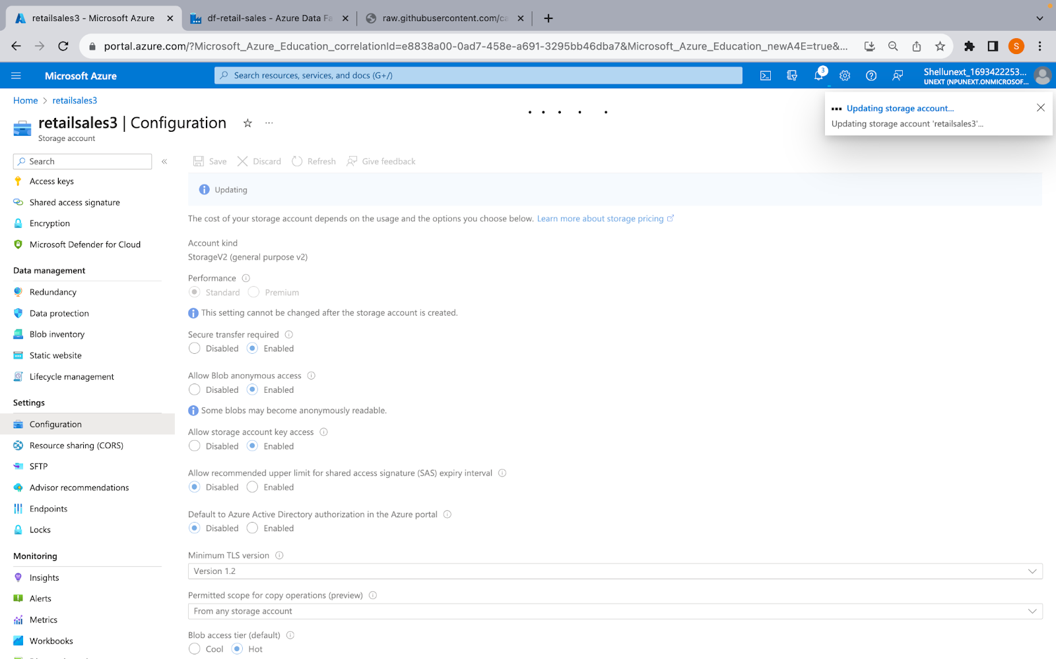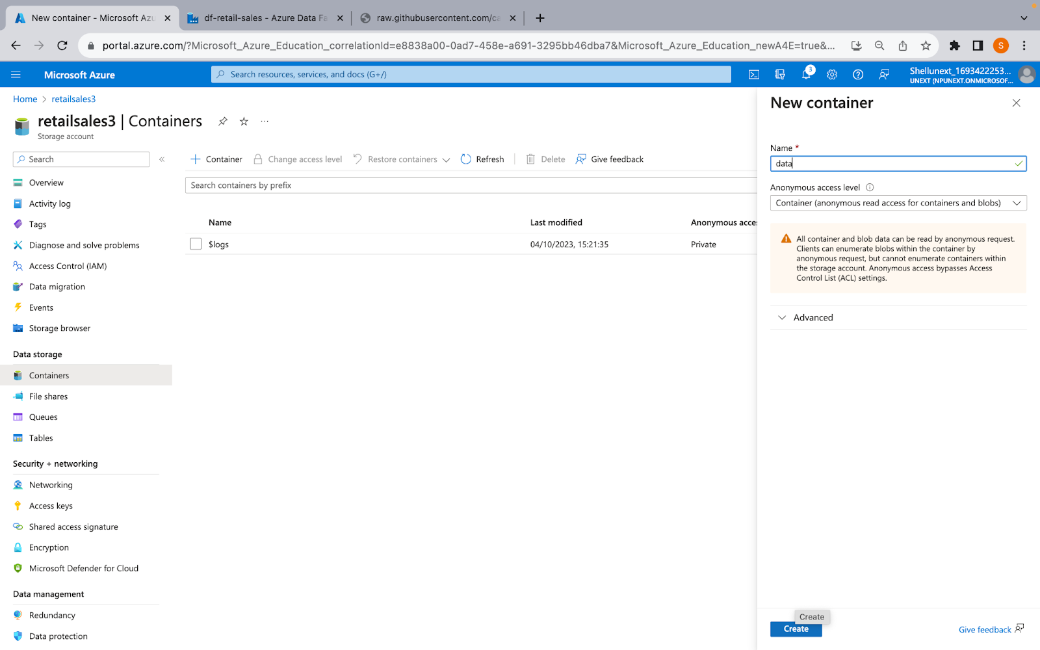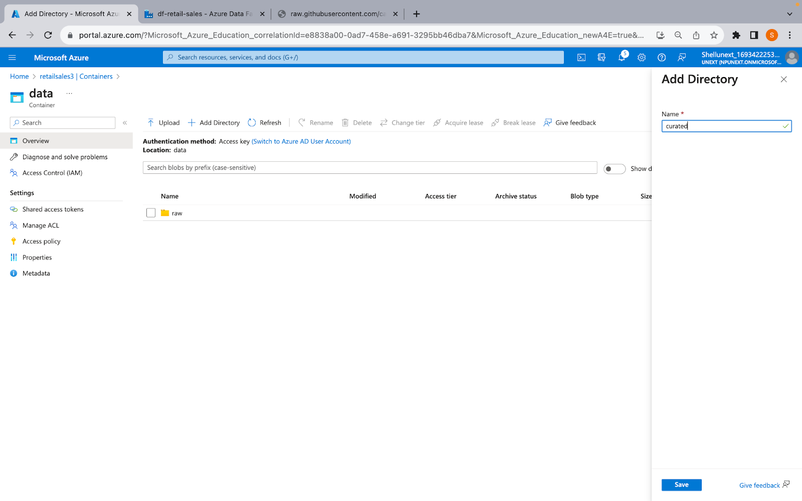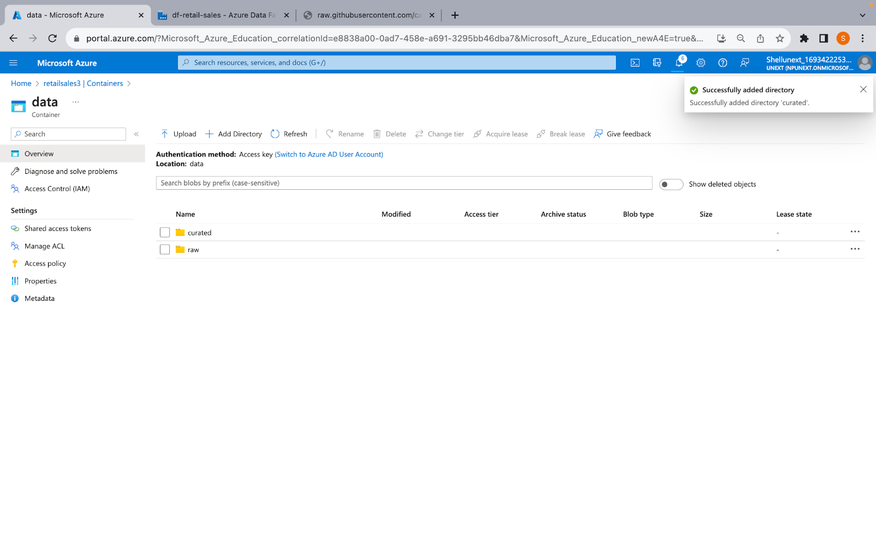

HTTPS Linked Service

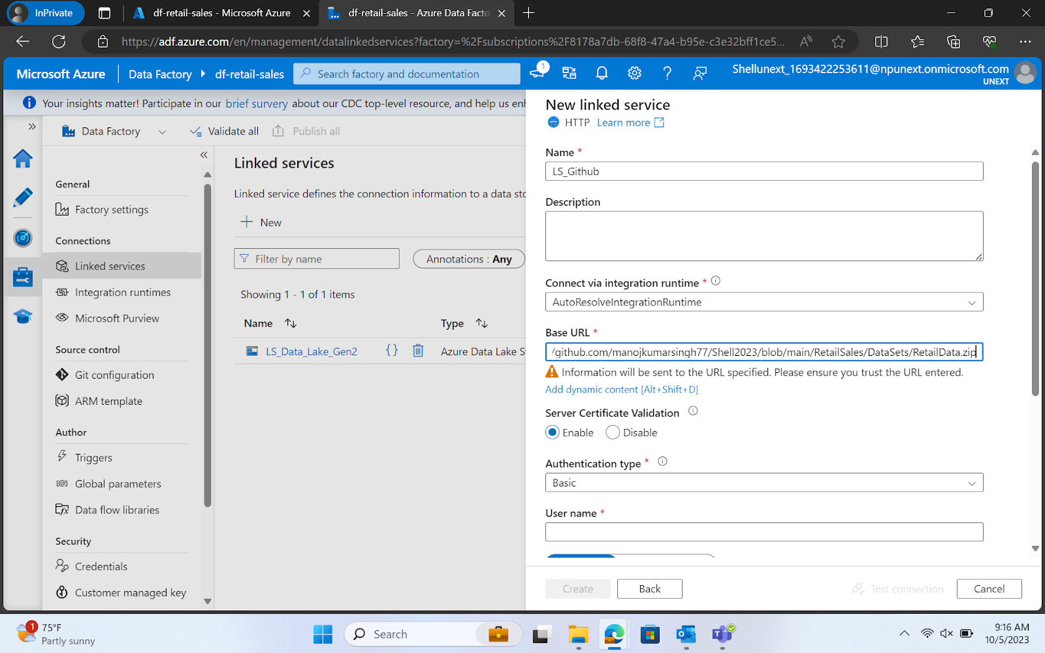

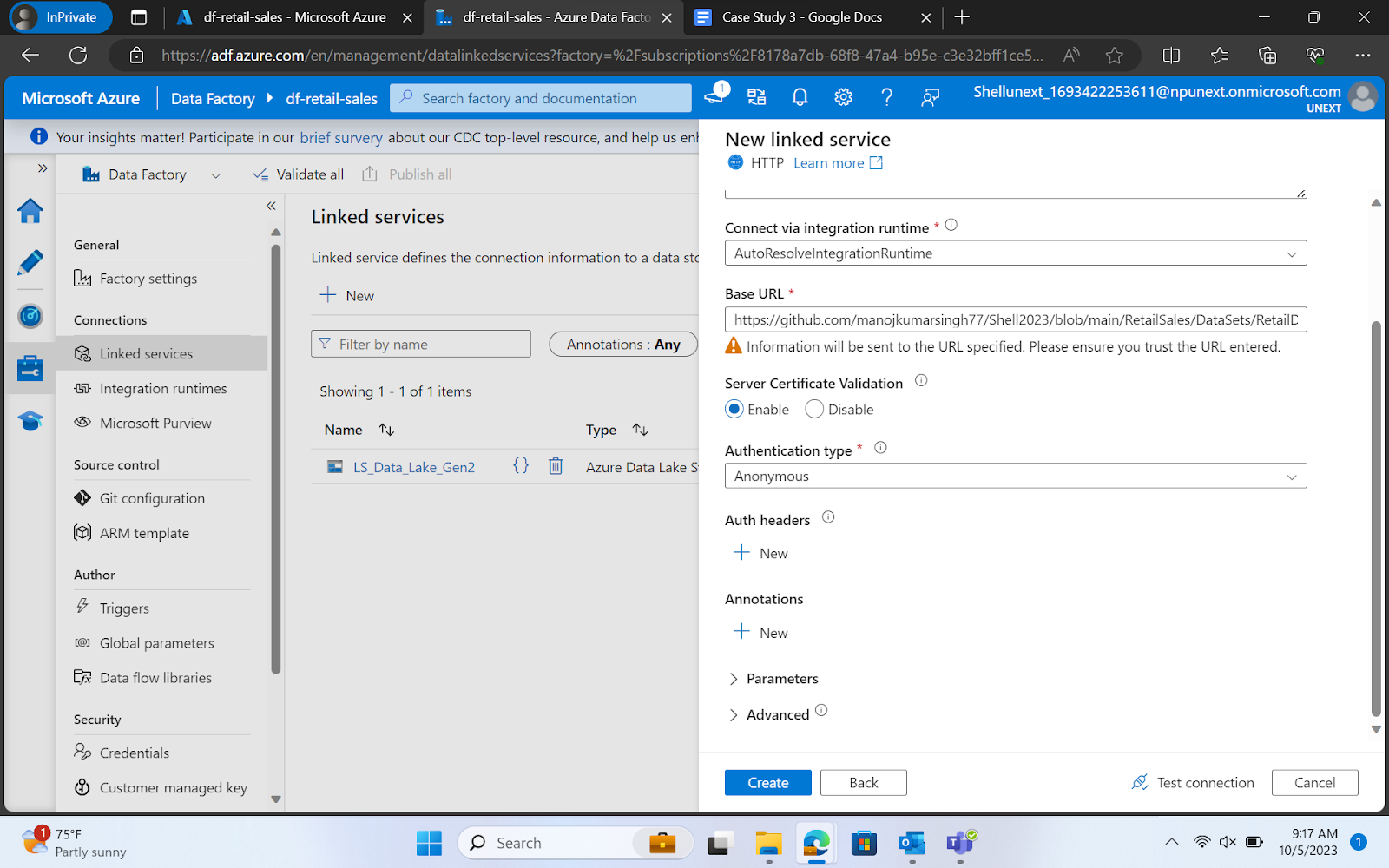

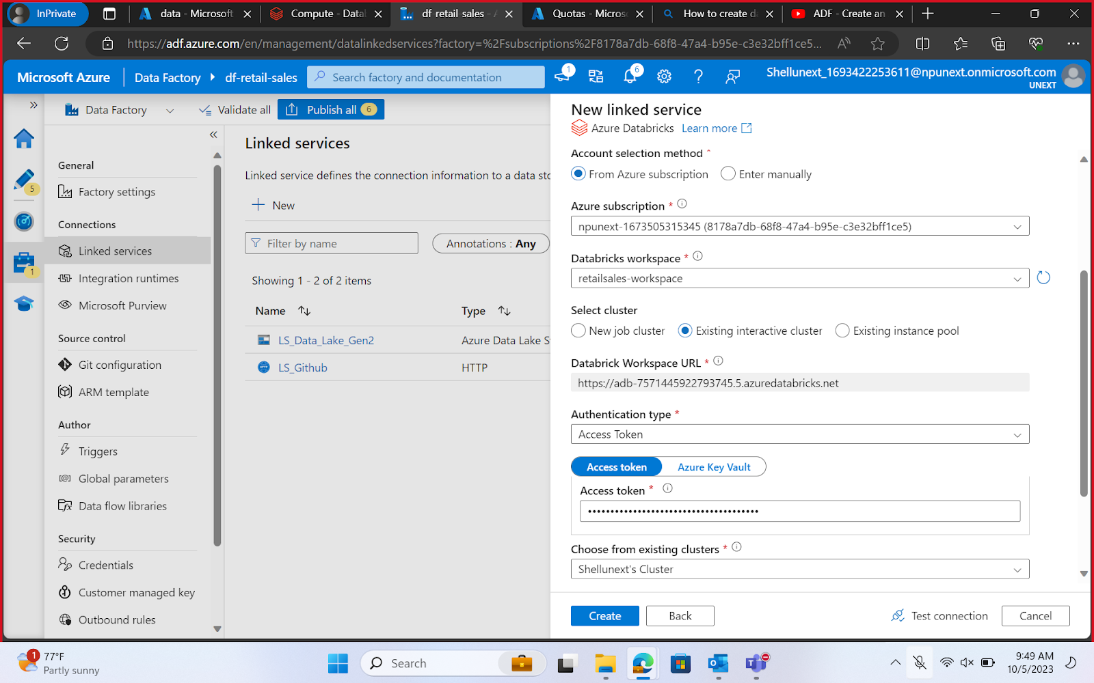



Databricks Linked Service

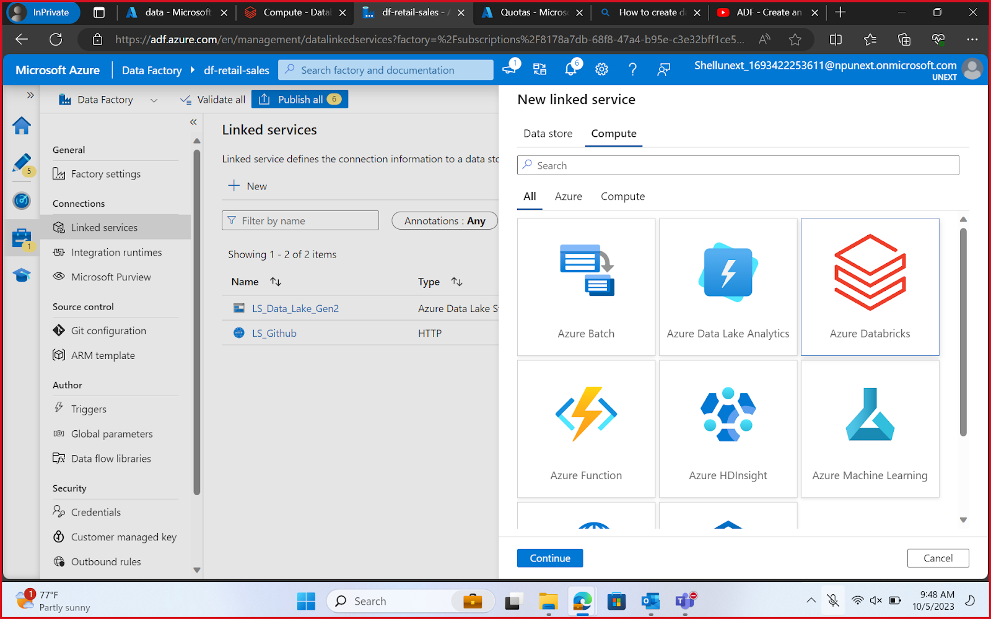

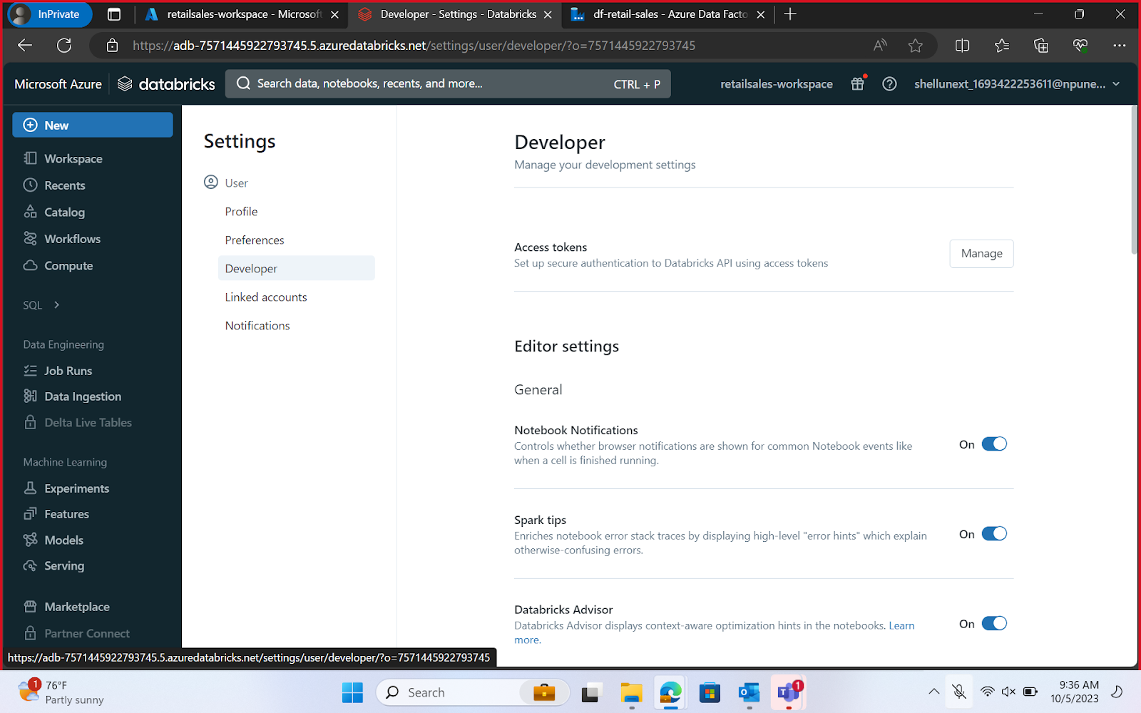

HTTPS Linked Service





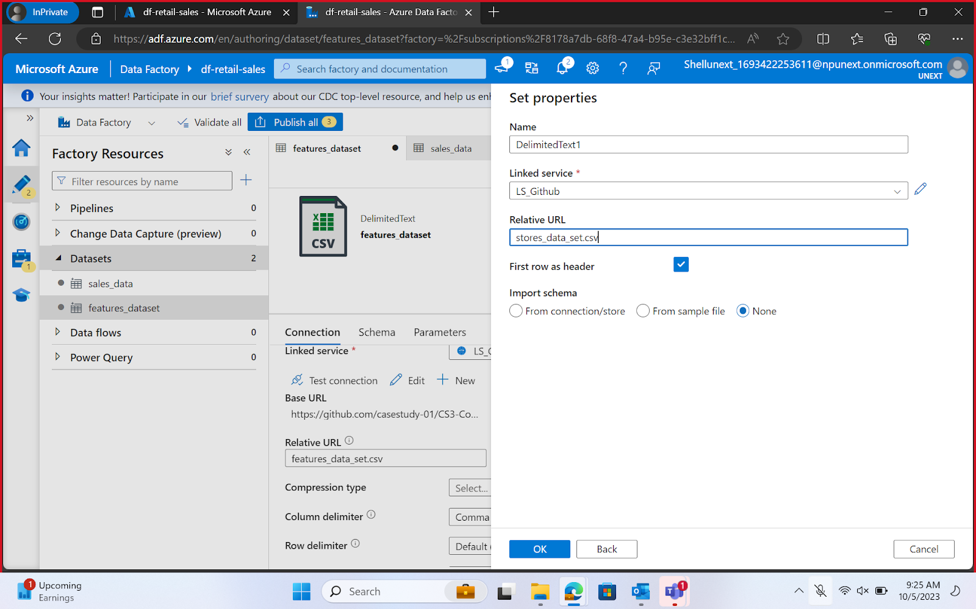

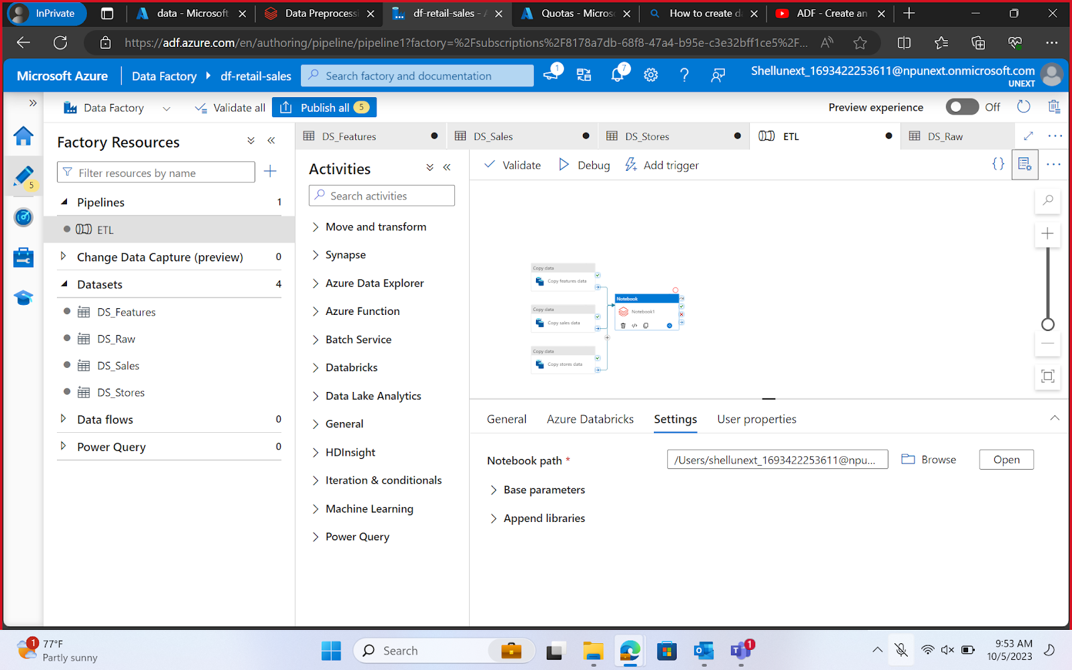

Databricks Cluster Creation

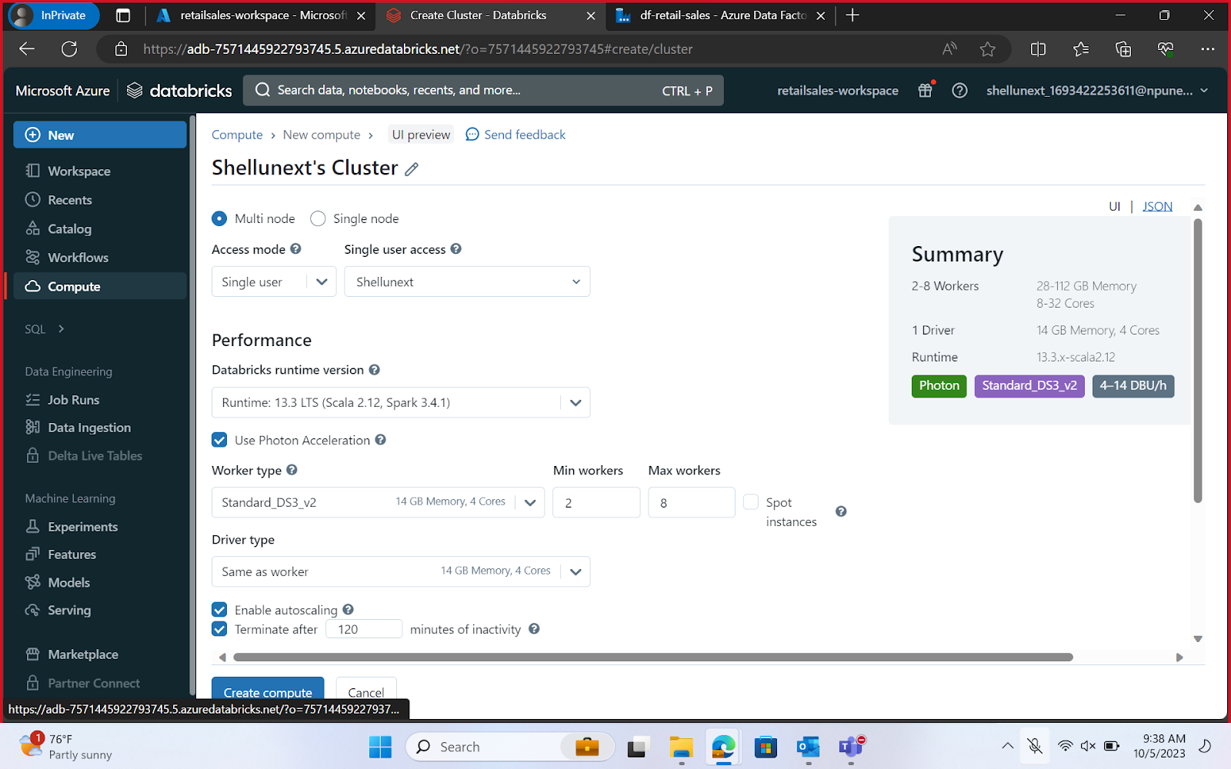

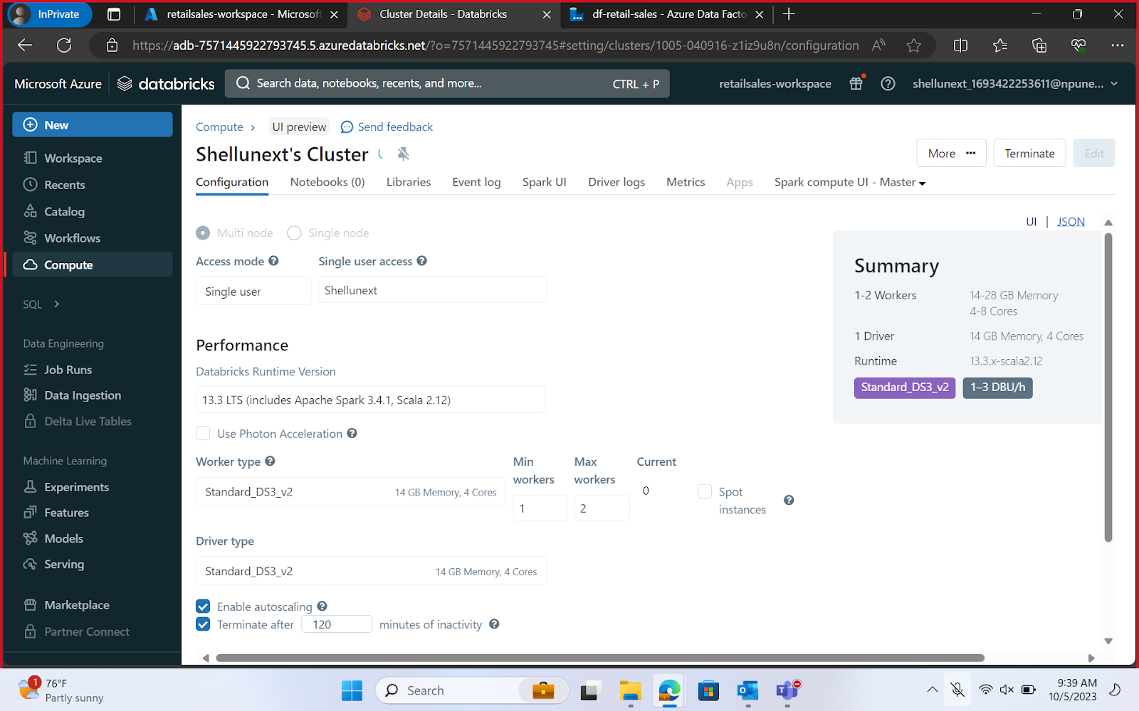

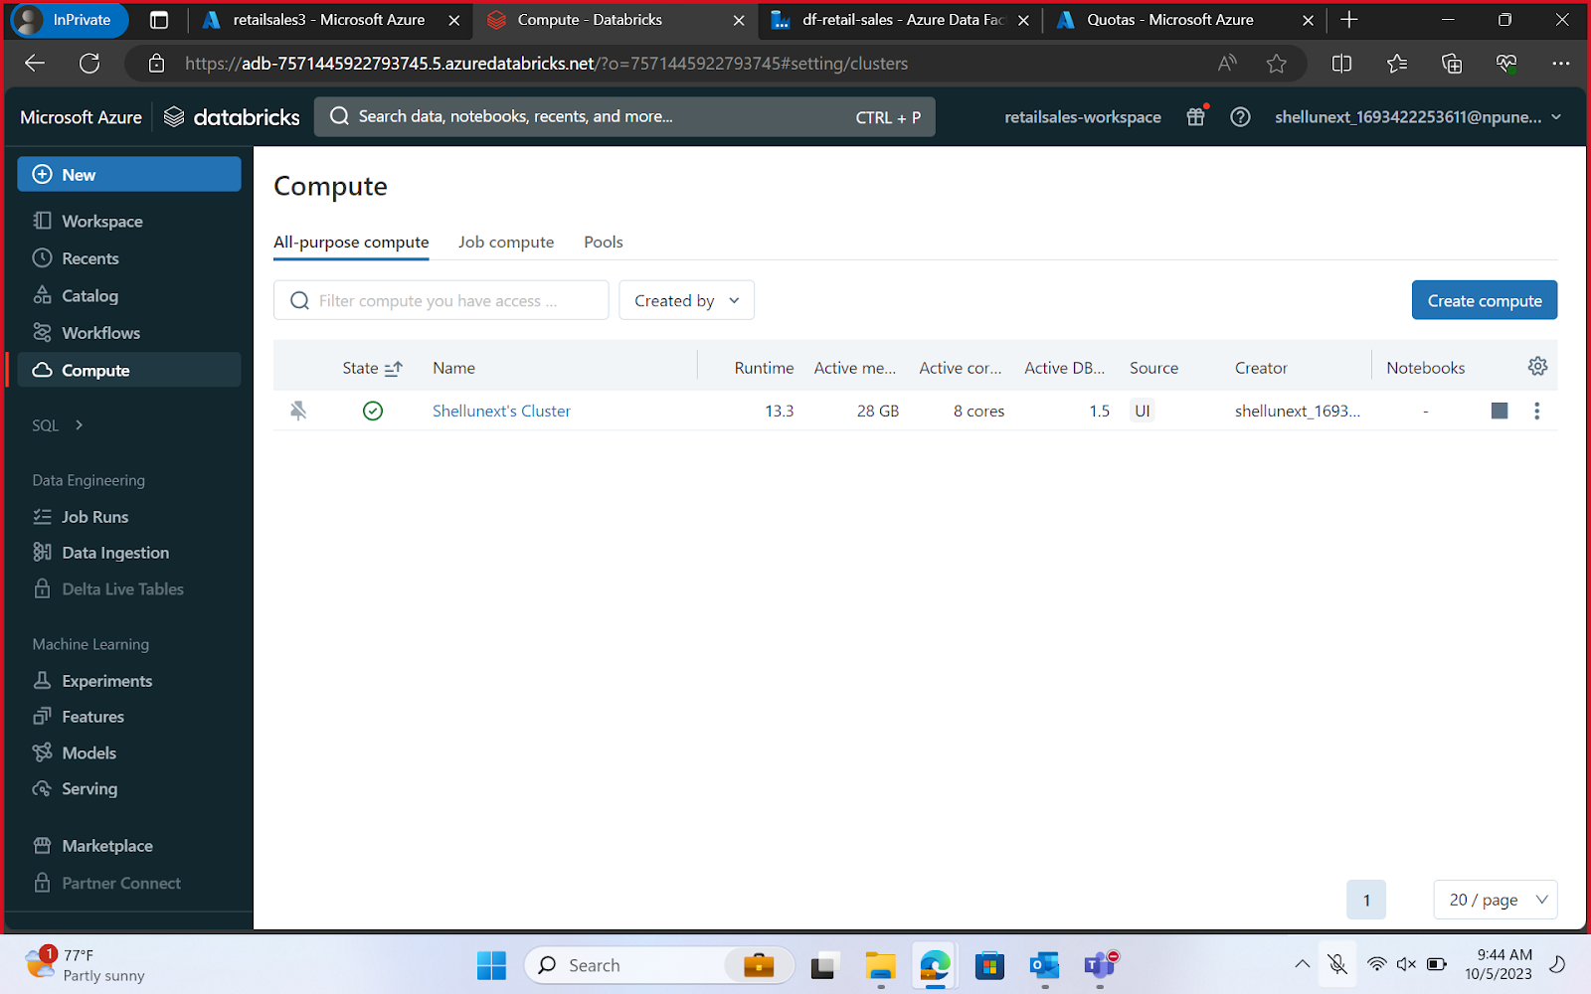

Creating ADLS Access Keys for Mounting the Storage on Databricks

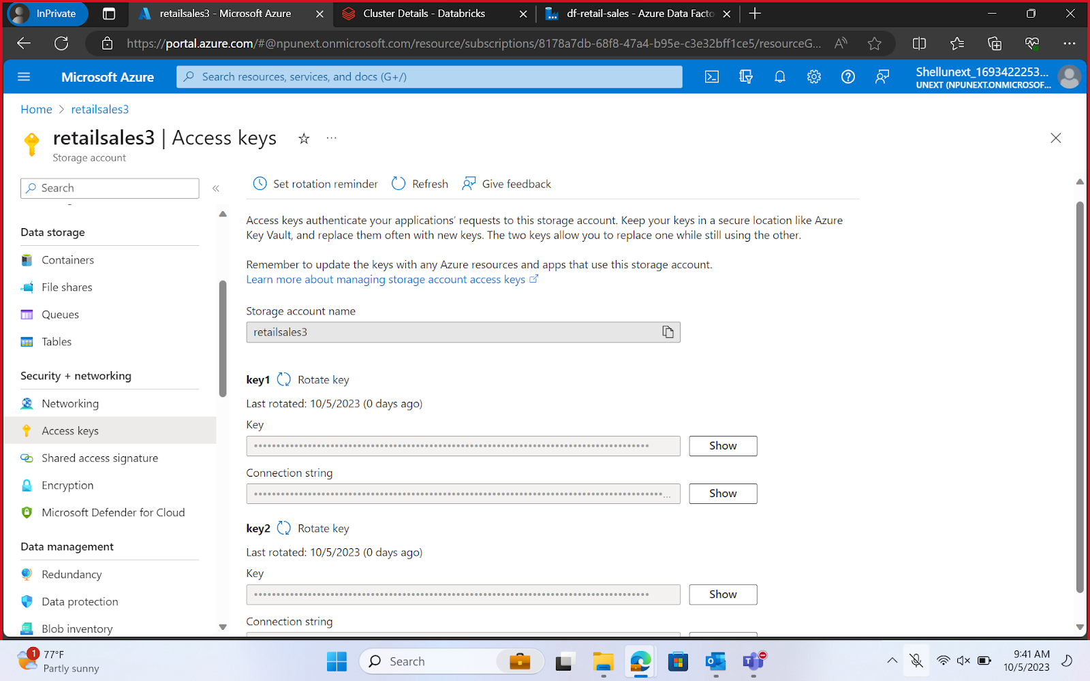

Mounting using Access Key

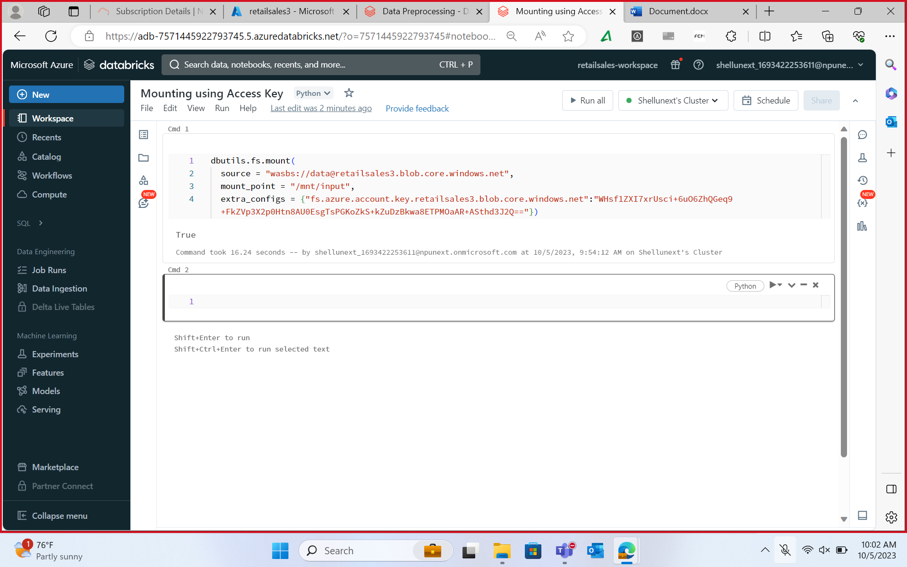

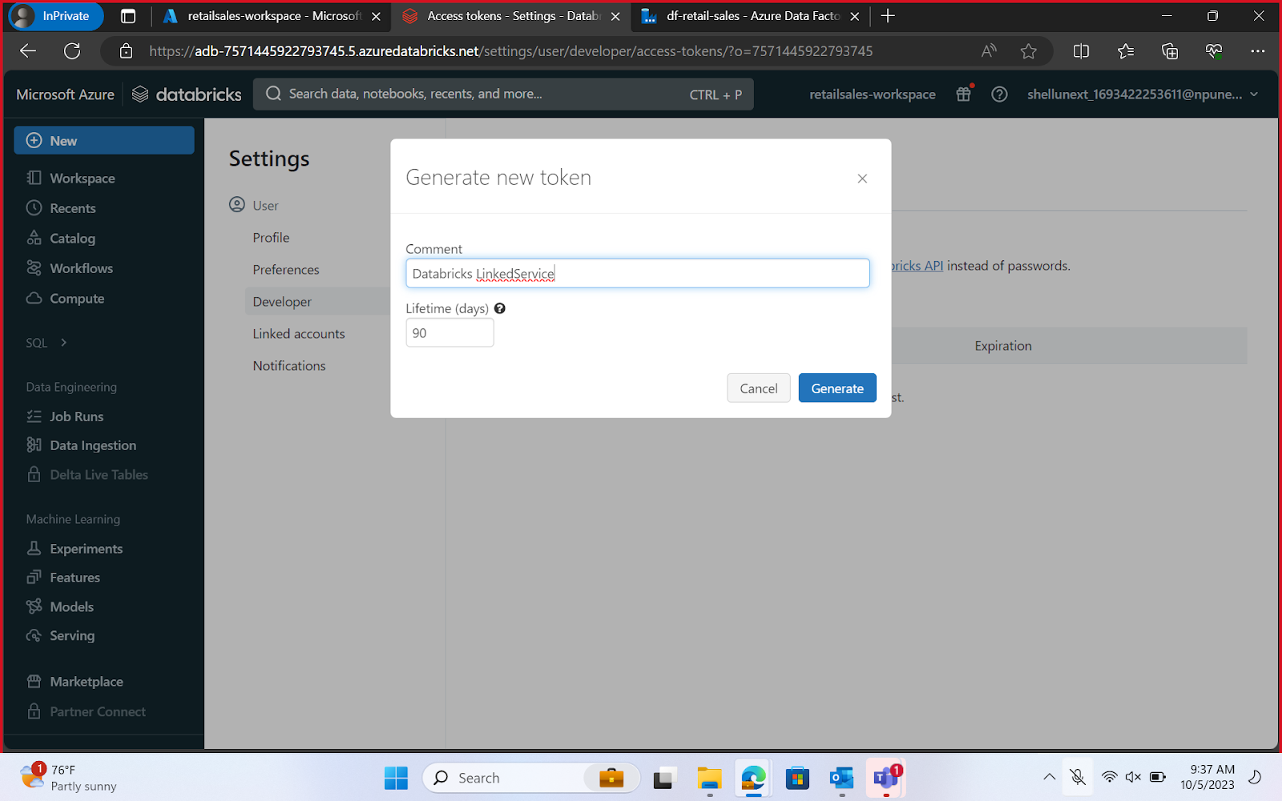

**Data Transformation -**  
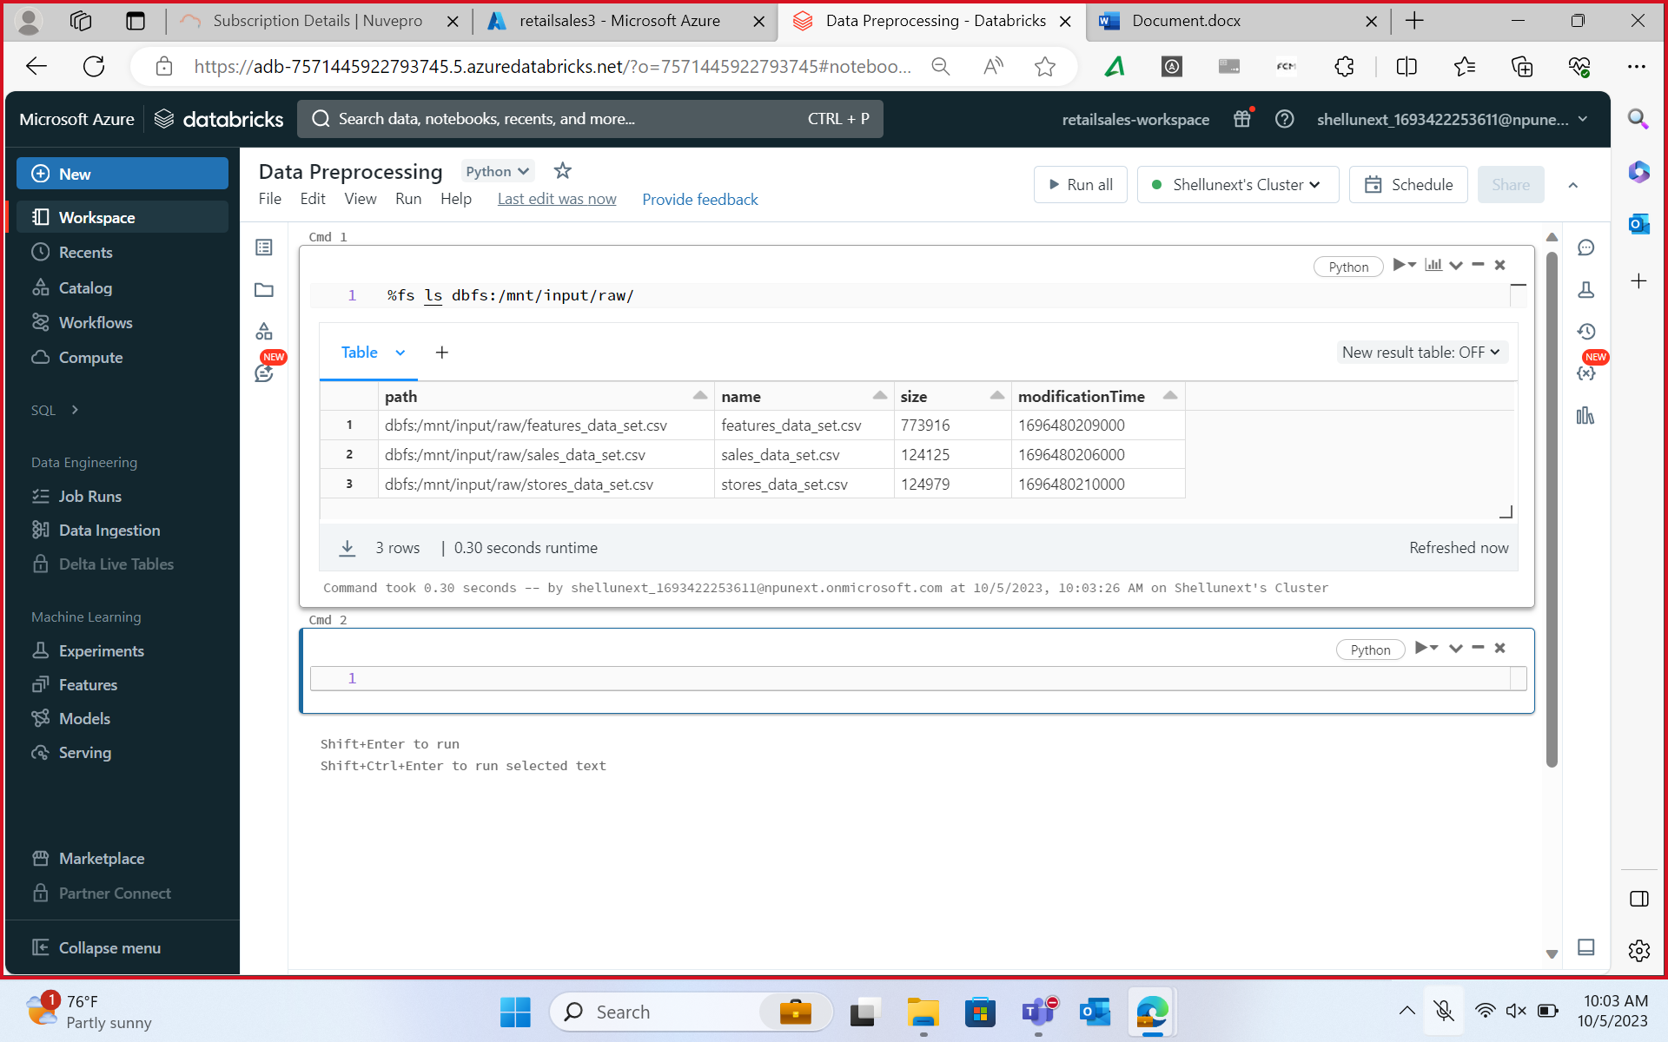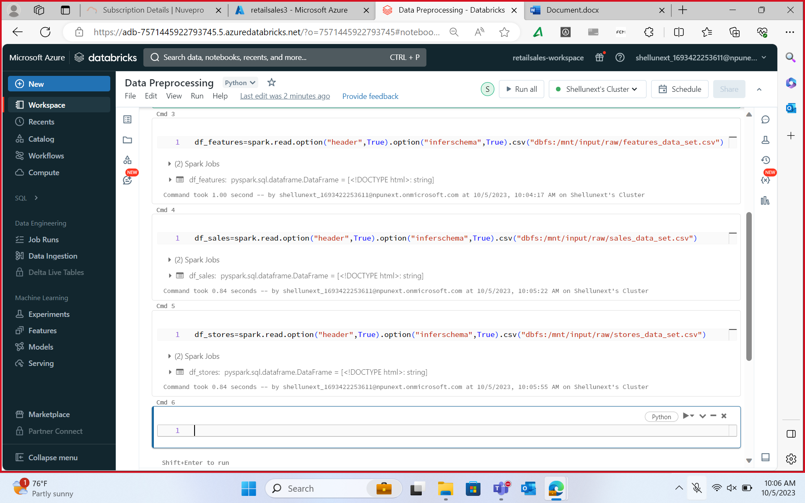

Azure Databricks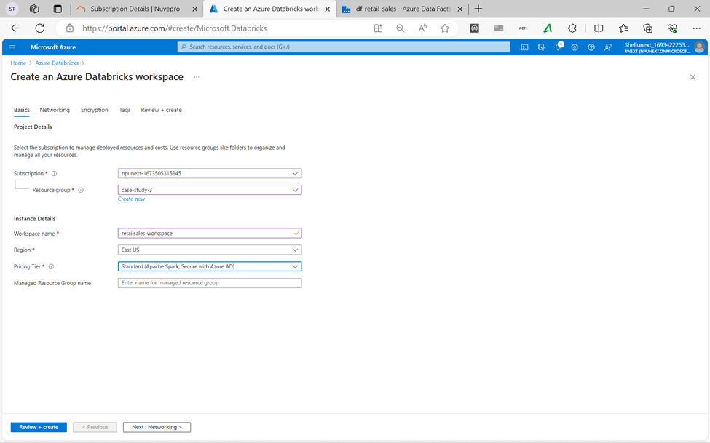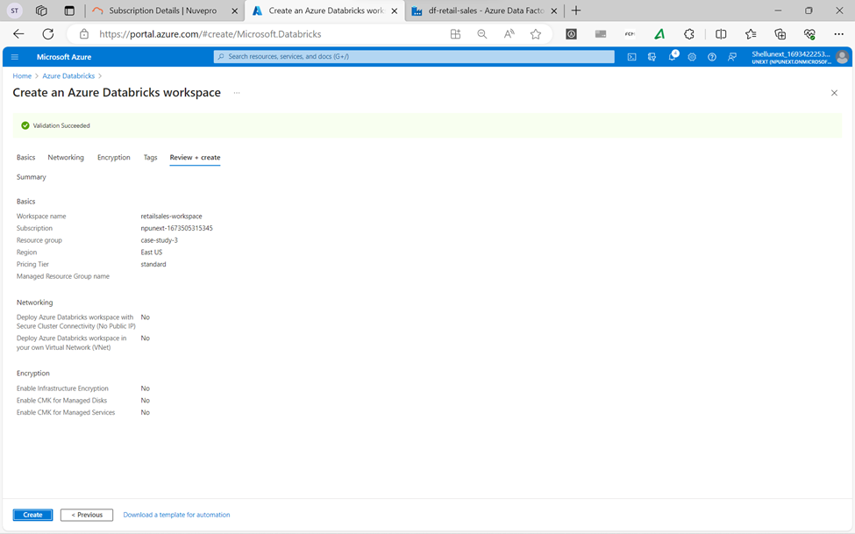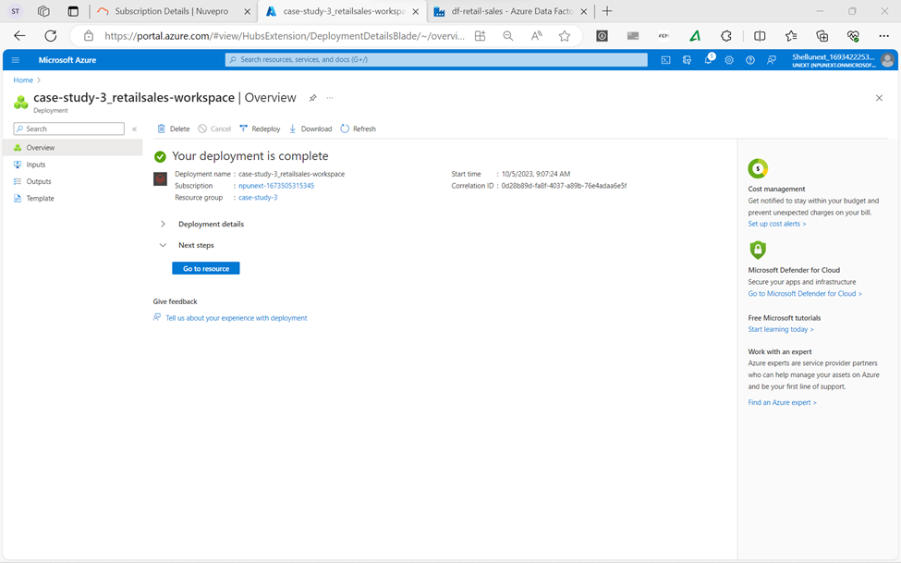

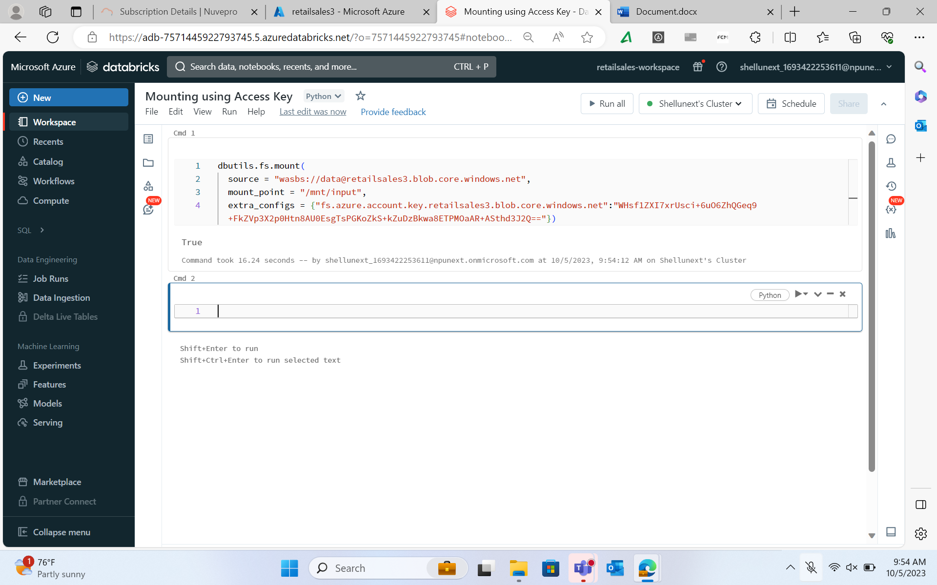

**Visualization of data-**

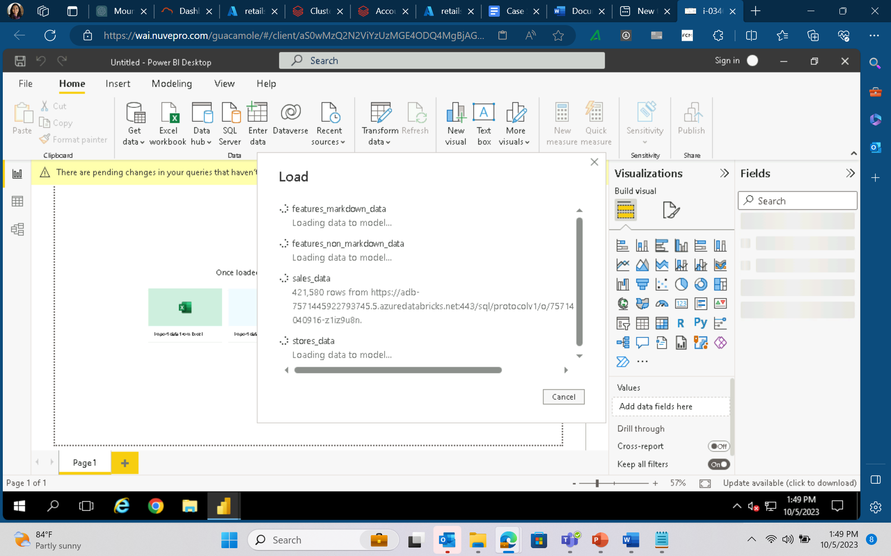

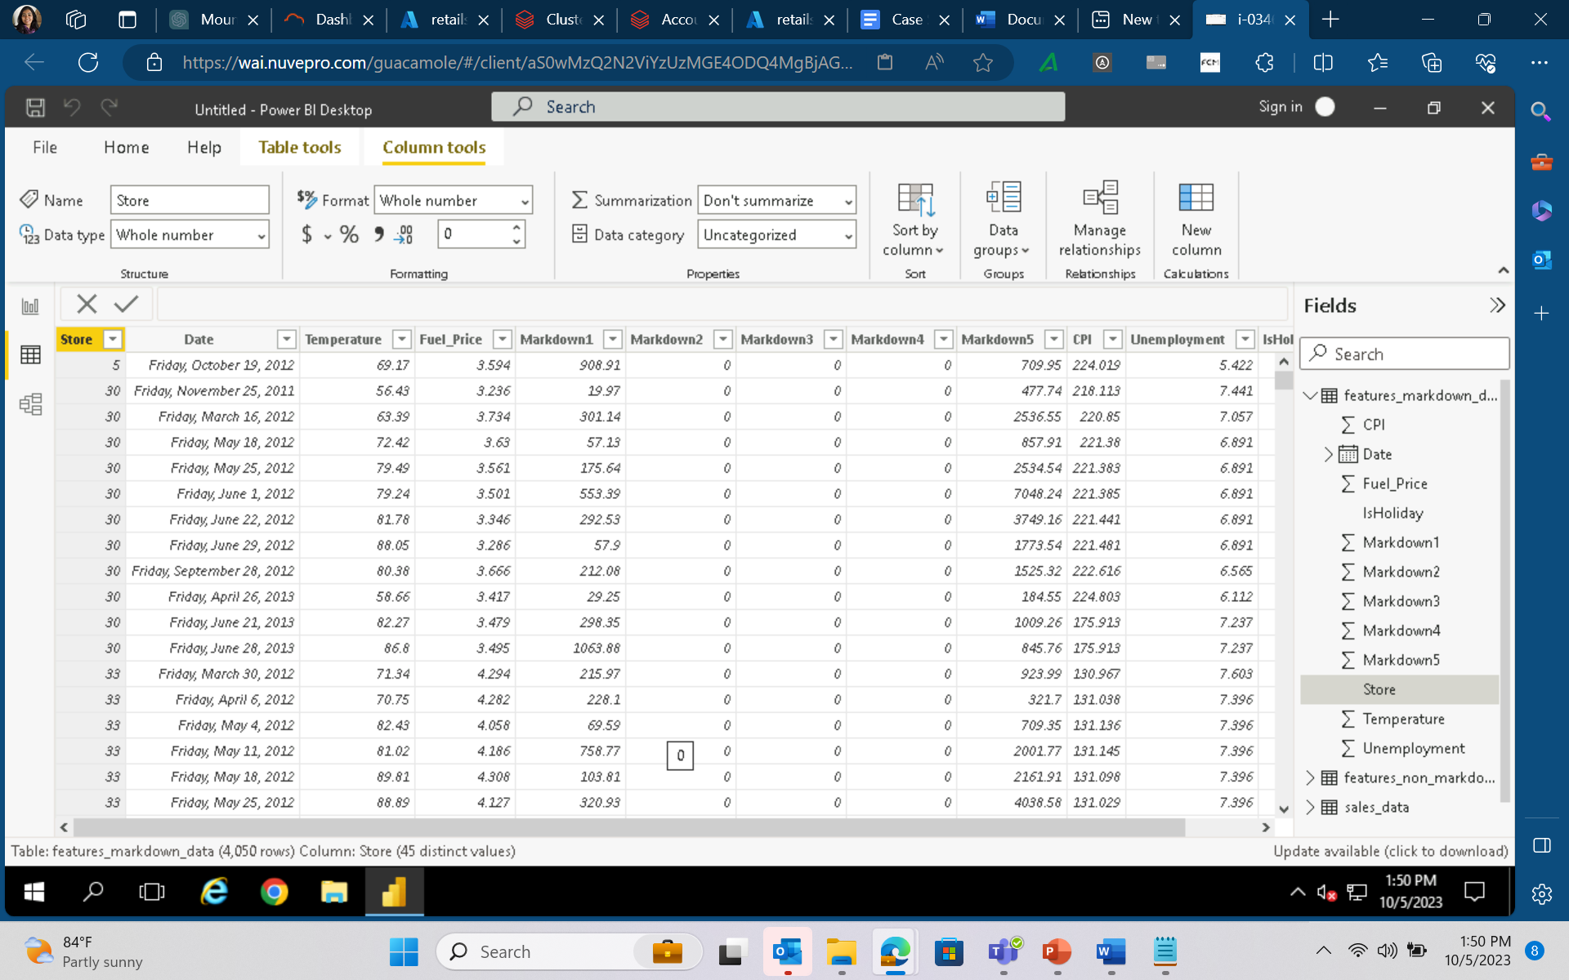

1. Holiday Impact Assessment:

a. How do sales figures during holiday weeks compare to non-holiday weeks?

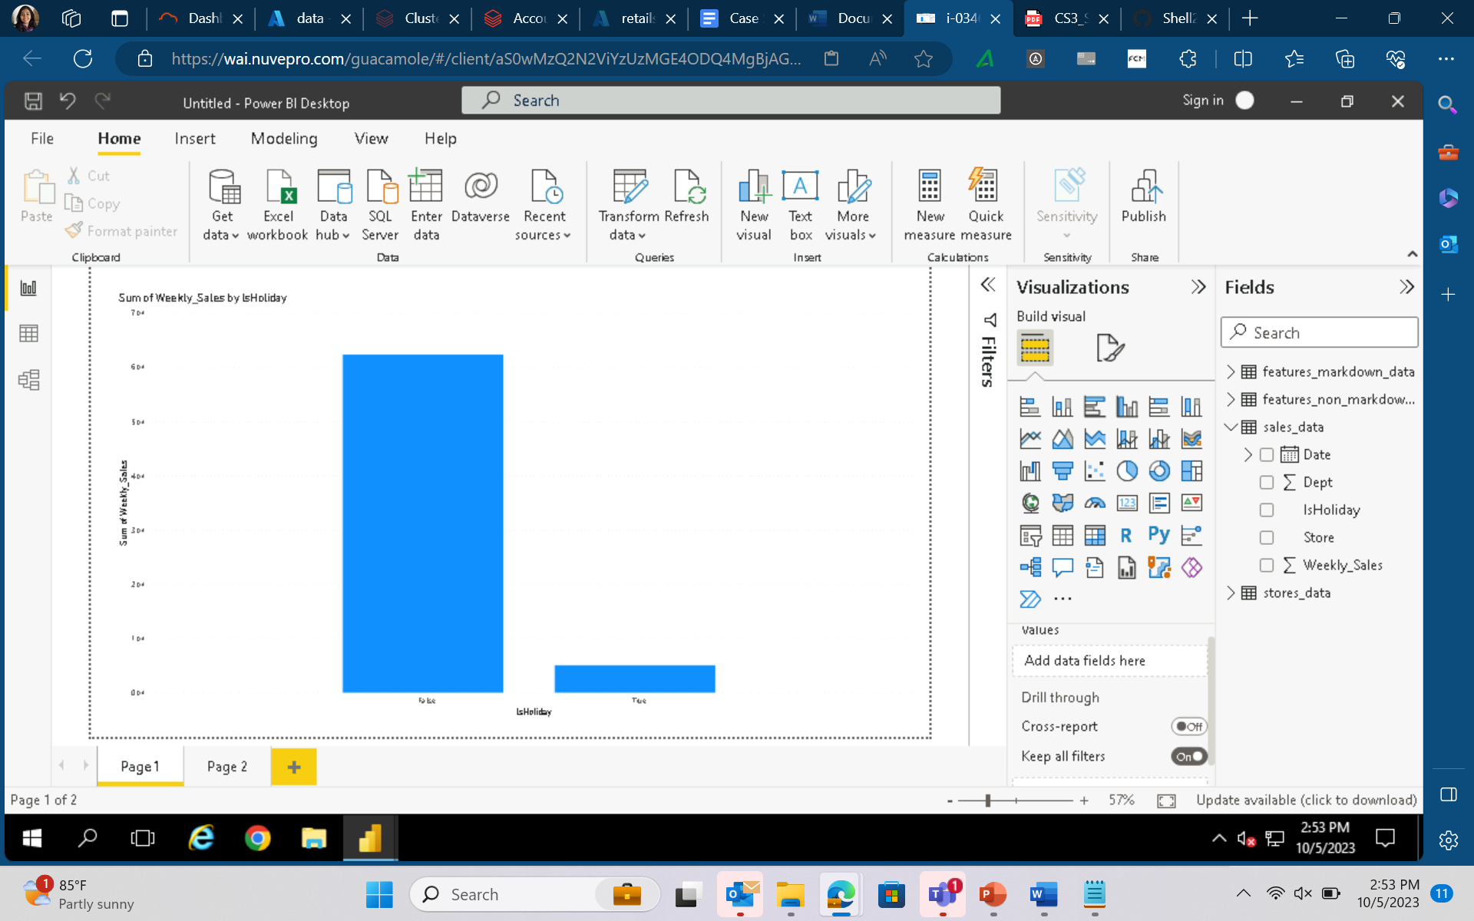

b. Which departments experience the most significant sales spikes during holiday periods?

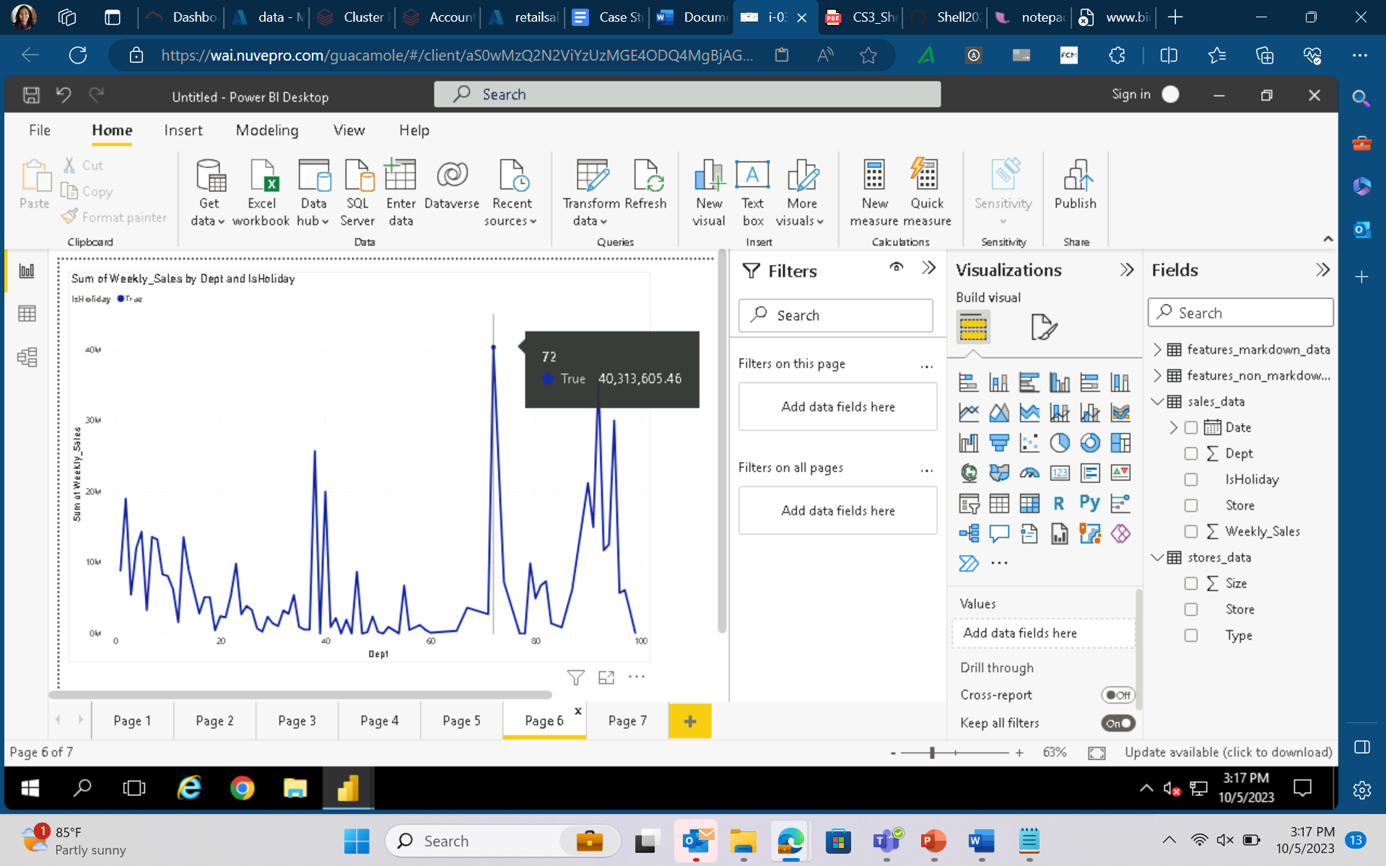

2. Store Performance Comparison:

a. How does the sales performance vary across different stores during holiday and non-holiday weeks?

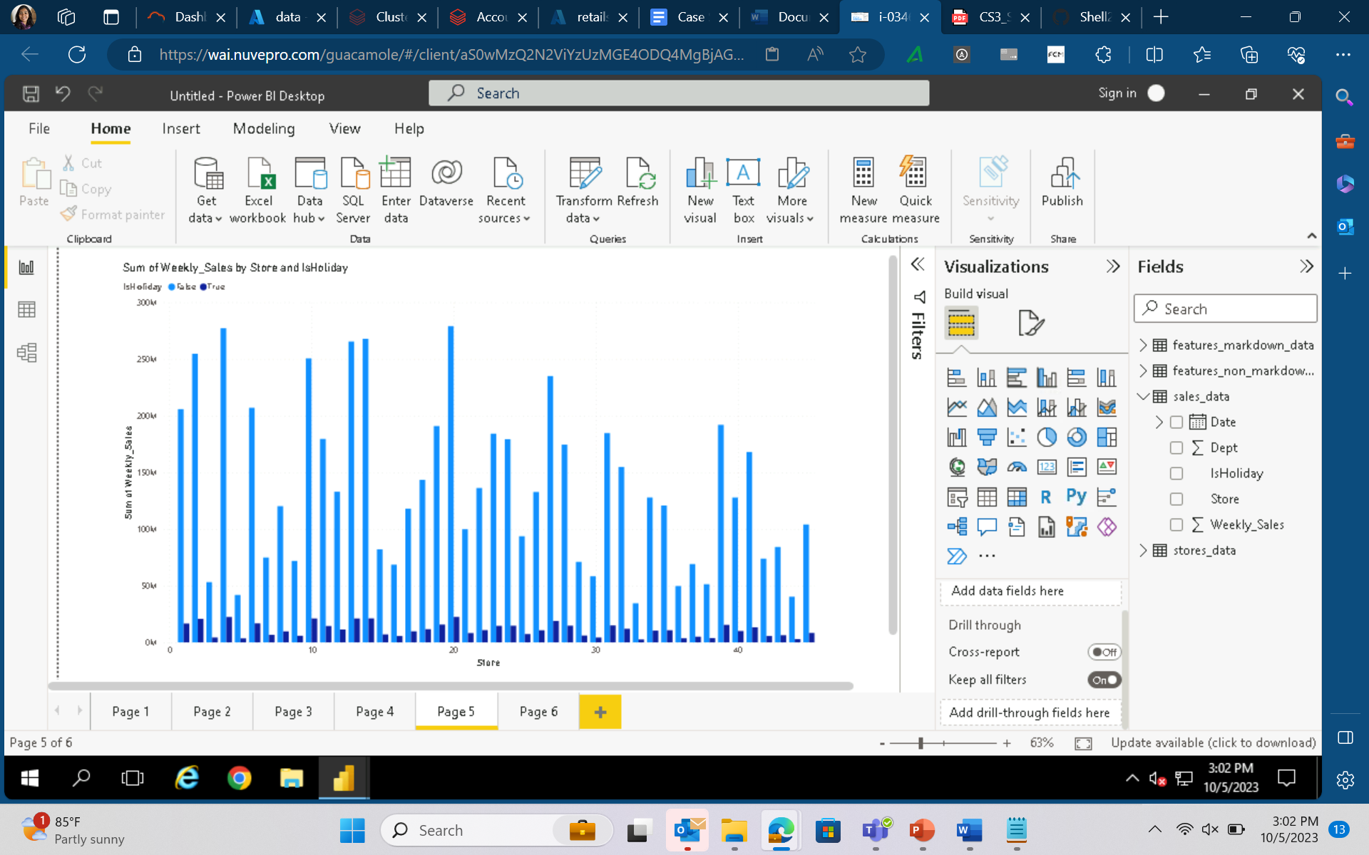 b. Which store from the data had the maximum sales?

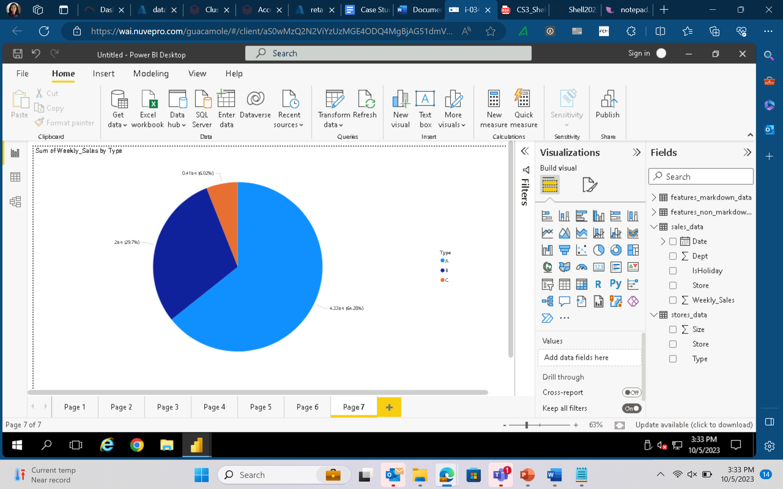

3. Region-Specific Analysis:

a. How do regional variations impact the effects of holidays and promotions on sales?

b. Are there regions where holiday impact is more pronounced, and if so, why?

